The Effects of Adding Stealth Gameplay to the Level Building Process of an Action Game

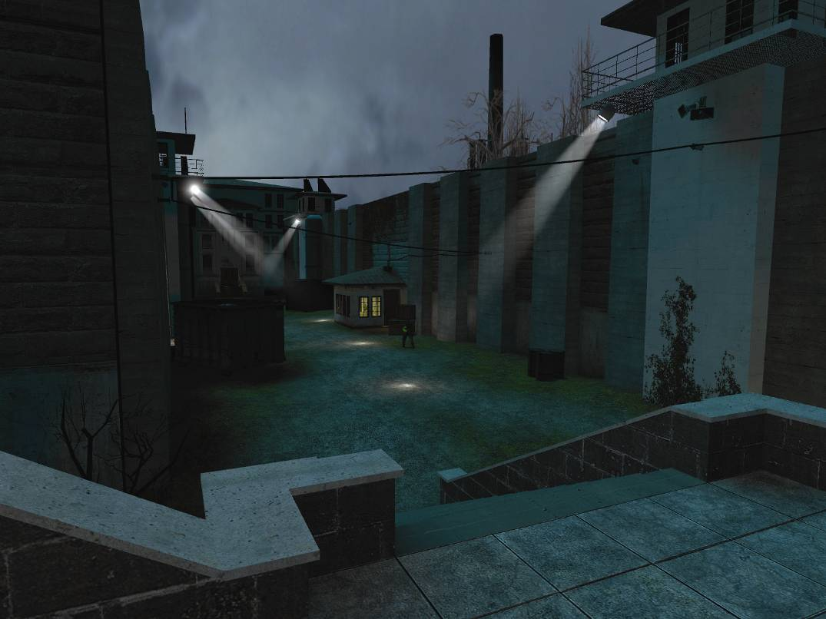

A Project Presented to the Faculty of The Guildhall
at Southern Methodist University
By Steve Baroski
(Bachelors in Computer Science, Susquehanna University, 2006)

In Partial Fulfillment of the Requirements for a Masters of Interactive Technology in Digital Game Development with a Specialization in Level Design
02/28/08
To the Graduate Faculty:
I am submitting herewith a project written by Steve Baroski entitled “The Effects of Adding Stealth Gameplay to the Level Building Process of an Action Game.” I recommend that it be accepted in partial fulfillment of the requirements for the degree of Master of Interactive Technology in Digital Game Development, with Specialization in Level Design.

_________________________________
NAME, Supervisor

I have read this Project
and recommend its acceptance:

____________________________________
NAME, Advisor

Accepted for the Faculty:

_________________________________
Dr. Peter Raad, Executive Director
The Guildhall at SMU
ACKNOWLEDGEMENTS
This project would have been impossible without the support of a whole bunch of people:
First of all, my deepest gratitude goes to my entire family who have supported me throughout my time spent at the Guildhall, both emotionally and financially. With out their support, I would not still be here today.
I am very thankful to the level design faculty at the Guildhall, who have been extremely supportive and have helped me develop my skills as a level designer.
My thanks go also to my fellow Cohort 7 students who, in addition to being just an all around great group of friends and comrades, also went out of their way to try and help out a fellow student in need when it came time to playtest.
Steve Baroski M.I.T., The Guildhall at SMU, 2008

The Effects of Adding Stealth Gameplay to the Level Building Process of an Action Game
Supervisor: Myque Ouellette
Master of Interactive Technology degree conferred May 5, 2008
Thesis / Project completed February 28, 2008

As video games increase in popularity and in quantity, there is a somewhat natural progression towards the mixing of various genres. Action games seem to be the most viable platform for this genre-mixing; Role Playing Game-style stat-boosting, puzzle-based or sports-based mini-games, platforming-style jumping puzzles, have all managed to seep into various action games, often in a hope to provide some variance to the gameplay experience. Stealth gameplay is one particular pseudo-genre that has even managed to become the entire focus of an action game, creating a new genre in and of itself. This begs the question, what exactly happens to the design process of an action game when an entire new gameplay style is introduced and uses the same playspace? Can one effectively create a level that satisfies players of both genres? This thesis aims to study the effects of adding a new gameplay style to an existing level that uses an almost contradictory play style.
The results of this study show that playtesters enjoyed both stealth gameplay and action gameplay when used in a single playspace. While there were certain conscious decisions and tools catered specifically towards stealth gameplay used during the design process, the result was generally positive, even with slightly flawed stealth implementation.

Table of Contents
List of Figures vii
Nomenclature viii
1: Introduction 1
2: Field Review 4
2:1 The Stealth Genre 4
2:2 Stealth Player Tools 6
2:3 The Action Genre & Common Concepts 8
3: Methodology 10
3:1 Overview 10
3:2 Game Engine 11
3:3 Stealth Implementation 12
3:4 Level Details 13
3:5 Level Abstract - Duality 15
3:5:1 Quick Summary 15
3:5:2 Gameplay Overview 15
3:5:3 Technical Overview 17
3:5:4 Details 18
3:5:5 Screenshots 20
3:5:6 Rough Map 27
3:6 Survey Questions 28
4: Results and Analysis 29
4:1 Demographics 29
4:2 Genre Ratings 30
4:3 Room-by-Room Analysis 31
4:3:1 Cell Blocks 4 & 5 - Figures 32
4:3:2 Cell Blocks 4 & 5 – Analysis 33
4:3:3 Cell Blocks 4 & 5 - Comments 34
4:3:4 Prison Yard & Guard Hall - Figures 35
4:3:5 Prison Yard & Guard Hall – Analysis 36
4:3:6 Prison Yard & Guard Hall – Comments 37
4:3:7 Entrance Hall & Lobby - Figures 38
4:3:8 Entrance Hall & Lobby – Analysis 39
4:3:9 Entrance Hall & Lobby - Comments 39
4:3:7 Average Ratings - Figures 40
4:3:8 Average Ratings – Analysis 41
4:4 Analysis Summary 42
5: Conclusion & Further Study 48
5:1 Conclusion 48
5:2 Further Study 49
References 51
Appendix A 52
Completed Surveys - Digital 52
Completed Surveys – Scans 59

List of Figures
Figure Page
2.1 Metal Gear Screenshot 4
2.2 Thief II: The Metal Age Screenshot 4
3.1 Guard NPC Entities 19
3.2 Cell Block 4 Screenshot 20
3.3 Cell Block 4 Screenshot 2 21
3.4 Cell Block 5 Screenshot 21
3.5 Cell Block 4/5 Passage Screenshot 22
3.6 Cloaked Overlay Screenshot 22
3.7 Prison Yard Screenshot 23
3.8 Guard Shack Screenshot 23
3.9 Yard, Post Alarm Screenshot 24
3.10 Guard Hall Screenshot 24
3.11 Lobby Screenshot 25
3.12 Entrance Hall Screenshot 25
3.13 Ambush Screenshot 26
3.14 Rough Map 27
4.1 Player Gender Demographics 29
4.2 Player Age Demographics 29
4.3 Genre Gameplay Ratings 30
4.4 Difficulty Rating for Cell Blocks 4 & 5 32
4.5 Fun Rating for Cell Blocks 4 & 5 32
4.6 Difficulty Rating for Prison Yard & Guard Hall 34
4.7 Fun Rating for Prison Yard & Guard Hall 34
4.8 Difficulty Rating for Entrance Hall & Lobby 37
4.9 Fun Rating for Entrance Hall & Lobby 37
4.10 Average Difficulty by Area 39
4.11 Average Fun by Area 39

Nomenclature
Term/Abbreviation | Description
HL2 | Short for Half-Life 2
Hammer | Level Editor for Half-Life 2
NPC | Non-Player Character; commonly used to refer to an enemy in a level
Entity | Generic Hammer term, refers to any NPC, prop, visual effect, sound, trigger, etc, basically anything that is not solid BSP placed in the editor.
Shooter | Short for First Person Shooter (FPS), a common type of Action game
Stealth game | Short for Stealth-Action game

1: Introduction

When it comes to gameplay styles and types, the stealth pseudo-genre is a particularly odd breed. More often than not, stealth gameplay attaches itself to another genre such as first or third-person action shooters, and although most consider it a genre, stealth games are, for the most part, simply gameplay additions to pre-existing action games. While the general focus of these games is sneaking around and avoiding confrontation, there is usually an action component on which the player can fall back. This action-based fallback has two main purposes: to draw action players in to the game and to give the player some leeway with the low tolerance for failure present in most stealth games.
This, in turn, raises an interesting dilemma for level designers working on a stealth-action game; the designers need to build a level that provides an entertaining experience regardless of the player’s play style. Like most action/shooter games, there is also a distinct divide in stealth-action games between designing single-player (SP) levels and designing multiplayer (MP) levels. While the vast majority of stealth games are single-player only, games like Splinter Cell: Pandora Tomorrow (Ubisoft 2004) and its sequels have shown that stealth-based multiplayer gameplay is possible. Granted, stealth-based multiplayer games are nowhere near as popular as their action-based counterparts, but Pandora Tomorrow’s success has shown that there is a market for these games.
As with any genre, the same challenge for level designers exists in both stealth-based single-player and stealth-based multiplayer levels: to provide a fun experience for the player(s). Since “fun” is a relative term, and can mean different things to different players, it is important to analyze what is fun in terms of a stealth-action game. Stealth games are inherently difficult for pure action gamers to enjoy since it requires a different play style; action games are typically very fast-paced, relying on twitch reactions, while stealth games tend to be slower, and rely on the constant tension of possible discovery. This is why many action gamers tend to play stealth-action games like a purebred action game, and why they fail, get frustrated, and quit. One of the most prevalent examples of this occurs in the original Splinter Cell (Ubisoft 2002). For the first half of the game, the player could go through shooting everything in sight. The player was encouraged to use stealth, but not required. While this made the game accessible, it also led to a rather abrupt halting point midway through the game. The CIA Headquarters level proved to be the stopping point for a good number of action gamers, since it required the use of stealth, and forbade the player from killing anyone. Strangely, while the CIA Headquarters level may have alienated many players, this gradual approach to stealth also made the game (and the stealth genre) more accessible to many players who had not been exposed to the genre before (this is based on the sales and reviews of the game itself and the longevity of the series as a whole).
While some action gamers’ frustration over stealth gameplay may be partially due to the players’ inability to adapt to a different play-style, the games themselves are also to blame. Stealth gameplay typically has a very low tolerance for failure; if discovered, the player has failed in some way. The way this situation is handled in-game depends on the game itself. While some games treat this as a game ender, creating the dreaded learn-by-death scenario, most stealth-action games tend to shift into the action gameplay, allowing the player to try to run and hide or fight their way out of the situation. This is an example of action gameplay taking place in a stealth play-space, and returns to the primary question at hand: Is it possible for a single play-space to effectively support both stealth and action play styles? Can a level designed specifically for stealth also double as an entertaining action level (or vice versa)?
The aim of this project was to determine whether a level design for an action game could handle stealth gameplay as well. The measure of success for this project is determined by the experiences of several playtesters, who choose between two versions of a level, one action-based and one stealth-based, which used the same playspace and give feedback on their play session. According to surveys taken by 14 gamers, it was determined that players generally enjoyed both versions of the level, and, although there were some minor gameplay tweaks that needed to be made, the project was relatively successful. These results show that while the action and stealth gameplay types are somewhat contradictory, the design process that goes into creating a level for those gameplay types is not as different as the genres themselves.

2: Field Review

2:1 The Stealth Genre
Before delving any deeper into the analysis of what makes a good stealth or shooter level, we should look into the current generation of stealth and shooter games and what exactly a “stealth-action game” (or, more succinctly, a “stealth game”) is. Wikipedia defines a stealth game as “a video game that, unlike traditional action games, revolves around patience, lurking, and avoiding detection (or getting rid of an enemy silently and quickly without calling attention) in order to complete missions.” The first successful stealth-based game was Metal Gear (Konami 1987), but beyond the initial entries in the Metal Gear series, the stealth genre was for the most part stagnant throughout the early to mid 90’s. The genre re-surfaced en force in 1998, with the release of games like Tenchu: Silent Assassins (Acquire 1998), Metal Gear Solid (Konami 1998), and Thief: The Dark Project (Looking Glass Studios 1998). These games and their respective sequels refined stealth-based gameplay and helped establish the genre as it stands today. Other games of note include Tom Clancy’s Splinter Cell (Ubisoft Montreal 2002), Syphon Filter (Eidetic 1999) and Hitman: Codename 47 (IO Interactive 2000), all of which expanded the genre in various ways. Following the initial boom in 1998, stealth gameplay began to seep into other, non-stealth-focused games, with varying degrees of success. While some of these game designs handled stealth gameplay, many fell short and ‘those annoying stealth levels’ simply ended up breaking the flow of what may have been an otherwise entertaining game.

Fig. 2.2 - Thief II: The Metal Age (Looking Glass Studios 2000)
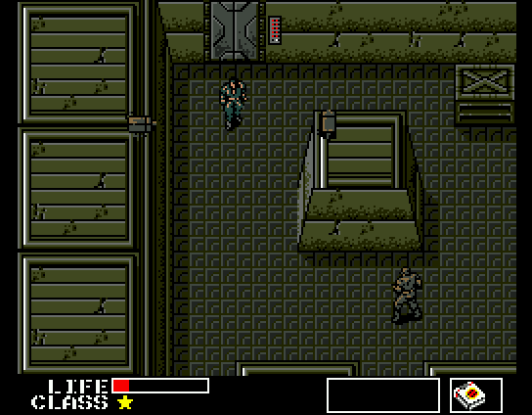
Fig. 2.1 - Metal Gear (Konami 1987)
While the basic stealth genre has grown in popularity and been influenced by other genres as a result, the core premise of avoiding detection has remained the same throughout. Although stealth-based games may have different objectives and gameplay styles than a shooter, there are some similarities between the design processes. Randy Smith, a level designer who worked on all three of the Thief titles, gave a presentation at GDC 2006 on the design process for stealth-based games. In the primer article from that presentation, “Level-Building for Stealth Gameplay,” Smith highlights that one of the key problems in level design for stealth-based games is providing a successful illusion. “If the level doesn’t appear challenging to break into then the player won’t feel powerful and stealthy, but if it really is extremely challenging to break into then the gameplay will be too difficult and too few players will be able to complete the level” (Smith 2006). Smith goes on to point out that, in addition to creating an effective illusion, designers need to create “level elements that enhance the player’s stealth powers by working with their tools. ‘Tools’ in this sense refers to the player’s inventory items but also refers to other types of player abilities and to elements of the level environment (Smith 2006).” In fact, the tools Smith describes provide both advantages and disadvantages to players; the job of the level designer is to balance these tools to provide an entertaining experience for the player (Smith’s website has a PowerPoint presentation that gives a more detailed explanation of all of the tools described below).

2:2 Stealth Player Tools
When designing for stealth gameplay, it is imperative that the level gives some sort of environmental advantage to the player. The player is out-numbered, and (presumably) out-gunned, so the only real advantage they possibly have is what the designers create for them. In order to make the level an entertaining experience, there also needs to be a number of challenges for the player to overcome. By giving the player a mix of both environmental advantages and challenges, any action level can become an entertaining stealth level. The tools that Smith outlines in his presentation are:
- Advantages
  - Soft Cover (shadows, bushes, etc)
  - Scouting Locations
  - Connectivity (multiple routes through or past an area)
  - Ring around the Rosy areas (player moves with an enemy to always ensure a something is between him and the enemy; pillars, etc.)
- Advantages/Challenges (can act as both)
  - Hard Cover (walls, wide corners)
  - Static Enemies
  - Patrolling Enemies (with predictable paths)
- Challenges
  - Blind Corners
  - Loud Surfaces (if sound is relevant)
  - Obstructions
Smith also makes special note of certain situations that either provide too great a challenge or would simply lead to player frustration:
- Things to avoid
  - Dead Ends
  - Unpredictable Enemy Behavior
  - Out of the frying pan into the fire scenarios (when running from one particularly difficult area simply drives the player into a more difficult area)

While the above list points out some of the differences between action gameplay and stealth gameplay, there are also numerous similarities, and designers can use many of the tools listed when designing levels for an action game. The playspace / level geometry for this project exploits these similar tools, in an effort to create a level that satisfies both play styles.
Since Randy Smith’s presentation focuses on stealth gameplay, the vast majority of the tools that Smith presents are specific to stealth games, but there are also a few that shooters use frequently. In particular, both shooters and stealth-based games can make effective use of connectivity and hard cover, and in general, designers try to avoid the negative effects of blind corners, obstructions, and dead ends. Granted, the reasons for using these tools is different in each case, but the fact that tools are present in the design processes for both genres shows that it should be possible to create a playspace that can be used for both play styles.

2:3 The Action Genre & Common Concepts
While the stealth genre is not as clearly defined as the action/shooter genre, the fundamentals of level design for first and third person shooters also apply to level design for stealth games, therefore there are certain core ideas that both genres share. Stealth gameplay is essentially an extension of shooter gameplay, with more restrictions on player abilities. In his book “Game Level Design,” author Ed Byrne (2006) outlines six key concepts to creating a fun level, regardless of genre:
- Player Ergonomics – No learning by death
- Difficulty – Let the player win, not the designer
- Flow – Keep the player moving
- Rhythm – Create a roller coaster rather than a highway
- Wow Factor – The water cooler moments
- Hooks – Setting your level apart

The first concept, Player Ergonomics is one area where stealth games tend to alienate players, and for good reason. In a shooter, “learning by death” typically equates to a situation where the player must perform some action to progress, but the only way to learn about this particular action is to die. While some stealth games go so far as to treat player detection as the equivalent to death (with a game ending once a guard or camera discovers the player), most stealth games are more forgiving, and provide a sort of cushion between detection and complete failure (death). This typically consists of a shift into an action gameplay sequence or some in-game tool that allows the player to escape and seek refuge (i.e. a flashbang).
While the difficulty of a level is often relative to the player, there are still base rules for creating an enjoyable and challenging experience for both genres. In action games, difficulty of a particular level often revolves around two things: the player’s status (health and ammo), and the enemies faced (number and/or skills). Generally, if the flow of a level is good enough, players do not need to “fight” with the environment and players can approach each challenge in any way they see fit. On the surface, there is a similar, free-form nature with stealth games: every guard or enemy presents a challenge, and it is up to the player to determine how to approach that challenge. One particular difference is that stealth games often have optimal paths through each individual challenge, and due to the low tolerance for failure, these optimal paths can sometimes be the only way past a particular challenge.
The other concepts presented by Bryne (Flow, Rhythm, Wow Factor, and Hooks) vary between the two genres, but are still present in some form. The speed of the Flow in an action game is naturally more rapid, but there is a similar desire to keep the player moving in a certain direction, whether it is towards a certain objective or away from a dangerous situation. The Rhythm of games in both genres tends to follow a roller-coaster timing, with stealth games relying on tension of discovery and action games relying on fast-paced, challenging enemy encounters to provide the peaks. The Wow Factor and Hooks of a level are similar in that they distinguish the level from the others in the game, and these present themselves in both action and stealth games.
The various unifying factors between the two level design methodologies for stealth and action games would indicate that it is possible to create a single playspace that can satisfy both gameplay styles. This objective of this project is to determine whether a level designed with both playstyles in mind is entertaining for players of both types of genres.

3: Methodology

3:1 Overview
This project utilizes two separate levels, one stealth level and one action level, each with the same basic layout, but slightly different gameplay mechanics in order to gather data to support the hypothesis that a single playspace can support two seemingly opposite gameplay types. The primary concern when designing one level to suit both shooter and stealth play styles is pacing. Typically, stealth gameplay relies on observation (scouting patrol routes, alternative paths, etc) and requires a bit of patience, and is, by its very nature, much slower than an action shooter; a level that takes 20 minutes to complete using stealth could take two minutes to complete using a “run-and-gun” play style. This, unfortunately, is an unavoidable consequence of the very genres themselves, and, as a way of lengthening the action gameplay experience, many action levels use “gates” that limit the player’s progression rate through a level. Therefore, instead of attempting to create a level that provides the same experience length, this project creates a level that provides an entertaining experience for both play styles.

3:2 Game Engine
The game engine used for this project was Half-Life 2 (HL2; Valve 2004), a First Person Shooter / Action game distributed with a level editor called Hammer. Development initially used only the base Half-Life 2, but midway through the development cycle, one of the game’s expansions, Episode 2 (EP2; Valve 2007) was released and some of the code used in that expansion was used to implement stealth gameplay. Initially, the project assumed that, in order to produce a passable stealth-based game, it would require considerable modification to the base HL2 engine. It was later determined that the existing code and in-editor scripting system supported most of the desired stealth mechanics. In the end, the only code modifications made were a weapon model replacement (replacing the crowbar with a stun baton from Half-Life 2: Deathmatch) and the addition of a console variable, which allowed the designer to disable the flashlight via a console command. All of the other stealth gameplay mechanics (listed below) were created using existing HL2 entities, and although some methods were impractical, they allowed the creation of stealth gameplay in HL2 without extensive code modifications, which would have required much more time to implement correctly.

3:3 Stealth Implementation
In order to get the desired behavior out of the various enemies (Non-Player Characters, or NPCs) in the level, existing artificial intelligence (AI) was disabled, and separate in-game entities gave the NPCs new “eyes” and “ears.” This seems inefficient, and may cause slowdown if used excessively, but thankfully, no noticeable slowdown occurred during playtests. The stealth gameplay mechanics implemented for this project include:
- Light Sensitivity – Heavy shadows render the player invisible to enemy NPCs – Accomplished by using trigger volumes that hide the player from NPCs when they are standing in them.
- Stealth Kills – If the player approaches an enemy from behind without being detected, they perform a one-hit instant kill when they attack – Accomplished by parenting a trigger volume to each NPC, which modified the damage done by a particular weapon, the stun stick.
- Guard NPCs returning to Patrol Paths after seeing player – (By default, NPCs go into attack mode when they see the player, and continue attacking until they or the player is dead. A predictable enemy patrol path is one of the Advantages/Challenges Smith mentioned in his GDC presentation.) – Accomplished by using a scripted sequence, which sends the NPC on his patrol path when triggered to do so, and also effectively renders the NPC deaf, blind and dumb (needed for the two features below)
- Reduced Enemy Viewcones – By default, enemies in HL2 have a viewcone of 180 degrees (meaning they can see enemies perfectly whenever they are standing next to them). Reducing this evened up the odds for the player – Accomplished by using scripted sequence to make NPCs deaf/blind, then attaching a second viewcone entity in front of the NPC, which acted as the eyes for that NPC.
- Reduced Enemy “Hearing” Radii – Enemies in HL2 have a rather large and sensitive hearing radius, which makes actually performing stealth kills without alerting other NPCs rather difficult – Accomplished by using scripted sequence to make NPCs deaf/blind, then attaching a separate microphone “ear” entity to the NPC.

3:4 Level Details
Surveys and playtests from gamers who consider themselves primarily action gamers and stealth gamers serve as the measure of success for this study (whether they found the level frustrating for stealth playthroughs, too difficult or boring for action playthroughs, etc). This project utilized two separate levels, both using the same level layout with different starting equipment and player abilities. The two versions of the level start out similarly, with the player locked in a prison cell. They manage to escape their cell when a rocket destroys one of the cell walls. At this point, the player acquires a melee weapon, and the level starts. In the action level, after the player takes out a nearby guard, they can pick up a machine gun and the level progresses like any other Half-Life 2 level, where they are able to shoot their way through. In the stealth level, the guards do not drop their weapons, so the player has to sneak their way through, with the melee weapon as their only means of defense. While the focus of the action level is on action, it includes some basic stealth gameplay mechanics (from the list above, only reduced enemy viewcones and stealth kills), so technically the player can choose to “sneak” their way through some parts of the level.
In addition to the base level design described in the level abstract, the constructed level also makes use of some of the stealth gameplay design tools Randy Smith outlined in his Game Developers Conference (GDC) 2006 presentation. The tools used in both versions of the level include Static & Patrolling Enemies, Hard Cover, Soft Cover, and Connectivity. While stealth gameplay is the primary application for these tools, many of them are also applicable to action gameplay. Still, since HL2 is an action game, creating a stealth level requires more of a focus on these tools in their stealth gameplay applications. In his presentation, Smith describes the process of designing a stealth level as a balancing act of player advantages and player challenges, and that designers make use of specific tools to create these advantages and challenges. The design procedure for this project was to design an action-centric shooter level with these core stealth gameplay tools taken into consideration every step of the way.
Since stealth gameplay revolves around avoiding enemy encounters, what happens when the player encounters an enemy is one of many ‘make-or-break’ situations. As stated earlier, a stealth game that simply ends when the player is spotted can quickly lead to player frustration, so it is imperative to avoid this. Changing over to action-style gameplay upon discovery is one option, though, for this project, there is a distinct split between the two versions of the level, with one level encouraging action, while the other encourages a stealth approach. In the stealth version, when an enemy discovers the player, the player has two options: run and hide, or try to attack the enemy head on. Running to a shadowy corner or out of the general area is the ‘encouraged’ method (via in-game hints/tips), though brute force is a viable option. Players can attack enemies head to head, but the only weapon available to the player, the stun stick, is relatively weak, and requires multiple (~10) attacks in order to kill an enemy. Against multiple opponents, attacking head on usually leads to a quick death.
The outcome of this project relies on two things: the creation of viable stealth gameplay in HL2 and the experiences of the playtesters. The amount fun (or lack thereof) the playtesters have when playing either the stealth or the action version of the level qualitatively determines whether intentionally creating a level to fit both play styles is a viable design practice. Each playtester completes a survey (see section 3.6 for the survey questions) upon finishing a play through, and the comments on those surveys serve as the measure of success or failure. The potential for partial success or failure exists (where one version of the level is more successful than the other), so the survey asks playtesters to give comments about the various sections of the level, and comment on what they liked or disliked. In addition to the level breakdown, there are also some questions about the playtesters preferences in play style and about the implementation of the stealth gameplay (mainly to determine if this has adversely affected their experience in any way). This data should qualitatively be enough to conclude about the success or failure of the project as a whole.

3:5 Level Abstract - Duality

3:5:1 Quick Summary

Duality is a level that allows two different playstyles, stealth and action, by placing the player in the same prison with two very different sets of equipment and tools at their disposal. In the stealth level, the player must sneak their way out of the prison, attempting to avoid confrontation at all costs. In the action level, the player must rely on their twitch skills to overcome overwhelming odds.

3:5:2 Gameplay Overview

3:5:2:1 General Game Flow

In Duality, there are two different physical maps, but each uses the same geometry, lighting, and layout. The only difference between the two is the player abilities and the enemy placement. As such, the flow differs between the two versions of the map; stealth gameplay is by its very nature much slower than action gameplay, as it requires some degree of patience. As a result, the flow of the stealth version of the map is probing and slower. Action gameplay is more about twitch skills and reaction time, so the action version of the map has a faster, run-and-gun pacing. Even though the focus of the action version of the map is on the run-and-gun gameplay, the map acted as a sort of ‘stealth-lite’ test-bed, to see what stealth mechanics the base HL2 entities could create. As such, there are some basic stealth features in the action version of the map, such as the ability to perform stealth kills and smaller enemy viewcones. These features however are relatively minor and the player can ignore them if they choose to do so.

3:5:2:2 Major Elements

Both Versions:
- Connectivity – Map has multiple/branching paths in certain areas of the level (using bottle-necking to bring player back to primary path), and areas with honey-combing hallways.
- Heavy Shadows/Soft Cover – Though a major element to the stealth version of the map, it also has an effect on the action version, affecting player visibility (intentionally).
- Scouting Locations – More useful for stealth gameplay but high ground or areas with good cover also provide a strategic advantage in combat.
- Hard Cover – Useful for both stealth and action gameplay. For blocking line of sight and bullets.
- Blind Corners – Action gamers need to be on their feet when coming up to a blind corner and the same applies to stealth gamers.
- Obstructions – Essentially the same as Hard Cover in its uses, though it can often break the flow if used incorrectly
- Static & Patrolling Enemies - An encounter against one enemy in a stealth game can present a significant challenge; in an action game, one enemy is insignificant.

Stealth Only:
- The stealth gameplay itself is a major element.

3:5:2:3 Major Objectives
Escape.
[Conditional] Turn off the Alarm.

3:5:2:4 Environmental Hazards
None

3:5:3 Technical Overview

3:5:3:1 Mission Location
- Setting: Nova Sedlo Prison, a rundown, non-descript prison building, similar to Nova Prospekt. Also uses certain elements from Bank building (with suppression device on the roof) from later in the game.
- Time: Night (little-to-no light coming from windows)
- Season: N/A
- Weather: N/A

3:5:3:2 Gametypes
- Singleplayer, Stealth
- Singleplayer, Action

3:5:3:3 Items/Powerups
    - Stealth Version
      - Weapons: Stunstick, (model/animations taken from HL2: Deathmatch) which allows player to perform stealth kills when they sneak up on an enemy. Weapons from fallen enemies can not be picked up.
      - Items: Health, Shields. No Flashlight.
    - Action Version
      - Weapons: Stunstick, Submachine Gun, Shotgun, Magnum, Assault Rifle
      - Items: Health, Shields, Ammo

3:5:3:4 Difficulty
- Hopefully the same for both versions, but dependant on player skill level: Hard-Very Hard

3:5:3:5 Enemies
- Overwatch Soldier (npc_combine_s, Normal Model)
- Elite Soldier (npc_combine_s, Elite Model)
- Manhacks (npc_manhack)

3:5:3:6 Mission Metrics
- Play Time:
  - Stealth: ~20 min
  - Action: ~5 min
- Map Size (width x length x height): 4428x5242x664
  - Gameplay Area 1 (Cell Blocks): 1632x1901x664
  - Gameplay Area 2 (Prison Yard): 1460x4404x664
  - Gameplay Area 3 (Lobby): 2223x1087x664
- Visual Themes: Base HL2 Prison &Urban assets.

3:5:4 Details

3:5:4:1 Theme/Mood
Even for the action version of this map, the level conveys a feeling of sneaking around, since the heavy shadows and lighting assists stealth players. This creates a tense atmosphere, where the player waits for something to go wrong. Even after the action starts, the intended effect is to have the player jumping at shadows.

3:5:4:2 Enemy Placement
Since the enemies present different challenges in the action and stealth gameplay, the amount of enemies and their placement within the map is different in each version of the map. The enemy placement and distribution is dependant on the version of the level being played (the stealth version of the level has less overall).

3:5:4:3 Gameplay Mechanics
- Prerequisite Skills:
  - Stealth: Basic HL2 controls and understanding of stealth mechanics (not required per-se, but helpful; explained via print out or text file)
  - Action: Basic HL2 controls.

3:5:4:4 Story
Combine forces have captured the player, Gordon Freeman, and sent him to Nova Sedlo Prison. Shortly after arriving at the prison, Resistance forces launch an attack on the prison, and manage to inadvertently release Freeman from his cell. Equipped only with a stunstick, the player must escape the prison, and if possible, find a way to help the Resistance forces outside the prison walls.
- Objective 1: Escape Nova Sedlo Prison
- Objective 2 [Conditional]: The Alarm has sent the prison into lockdown; you’ll need to find the control panel to shut down the shieldwall in order to progress.

3:5:4:5 Enemy Abilities
The standard NPCs in Half-Life 2 were created with the action-centric gameplay of Half-Life 2 in mind, so the design called for changes to the base NPCs in order to make them usable in stealth gameplay. The figure below shows the changes/modifications made to each enemy NPC:
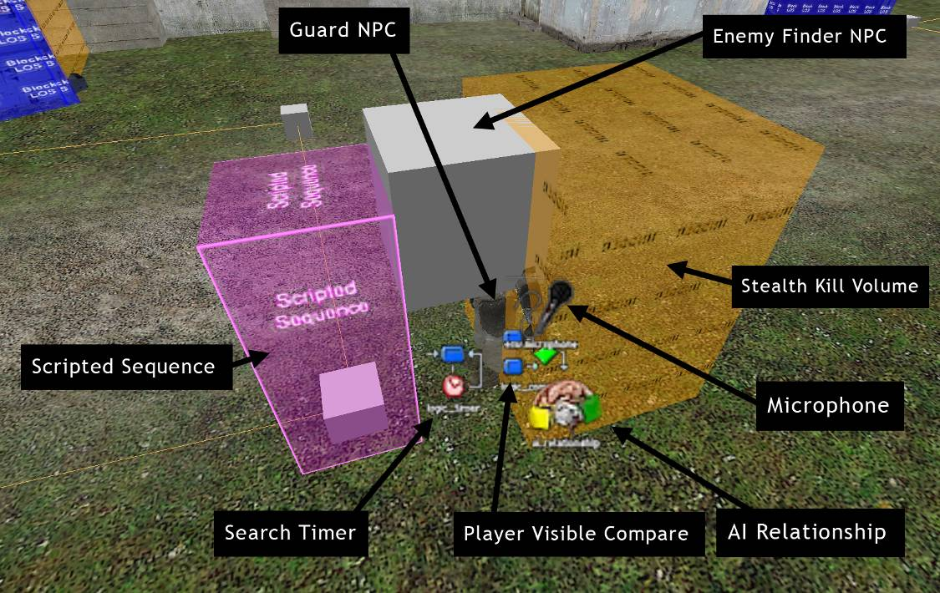
Fig. 3.1 – Guard NPC Entities

Description of each entity and what it does:
- Guard NPC (Hidden underneath the mess of entities, his leg and arm are visible) – Basic npc_combine_s entity, acts as the “parent” of all of the other entities (all other objects in the above screen are parented to the Guard NPC, and move with it)
- Enemy Finder NPC (large grey cube) – This is actually a separate NPC (npc_enemyfinder) that is attached to the Guard NPC. It acts as the Guard NPC’s eyes; used so I could control what happens when (and if) the Guard NPC sees the player.
- Stealth Kill Volume (orange cube to the right) – Attached to the Guard NPC; when the player walks into this volume, a visual effect overlay is put on the screen, and the damage dealt by their melee weapon is increased dramatically.
- Microphone – Attached to the Guard NPC; acts as the Guard NPC’s ears. Used so I could control what happens when the Guard NPC hears the player, and the distance at which it can hear the player.
- AI Relationship (brain with two shaking hands) – Sets it so, by default, the Guard NPC ignores the player, essentially stifling its hard-coded behavior to attack on sight.
- Player Visible Compare – Checked every time the Enemy Finder NPC “sees” the player; this entity checks to see if the player is currently visible (ie not in a stealth volume). If the player is invisible, it does nothing; if not, then it tells the Guard NPC to go into attack mode.
- Search Timer – Controls the Guard NPCs “search” time after the Enemy Finder NPC has lost sight of the player. This turns on if the player has been seen already by the Enemy Finder NPC, but has managed to hide. It counts down for ten seconds, and if the Enemy Finder NPC has not seen the player again in that time, it resets and tells the Guard NPC to go back to its patrol (via the…)
- Scripted Sequence (big purple cube) – This entity does two things: it renders the Guard NPC deaf, dumb, and blind, and it acts as the starting point for the Guard NPCs patrol path. Without this, the Guard NPCs behavior would become unpredictable after he had been sent into attack mode, and it would also make it difficult to control what AI messages the Guard NPC should ignore.

3:5:5 Screenshots

3:5:5:1 Cell Blocks 4 & 5

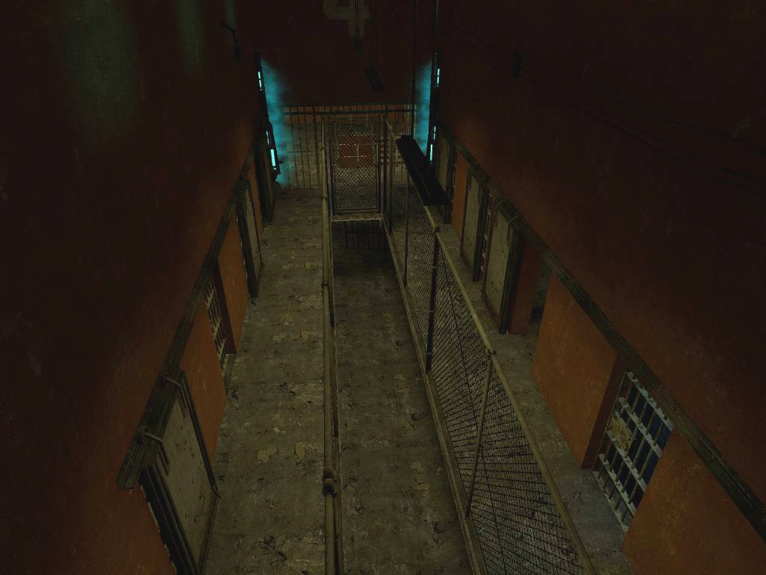
Fig. 3.2 – View from just outside the players cell (the starting point of the level)
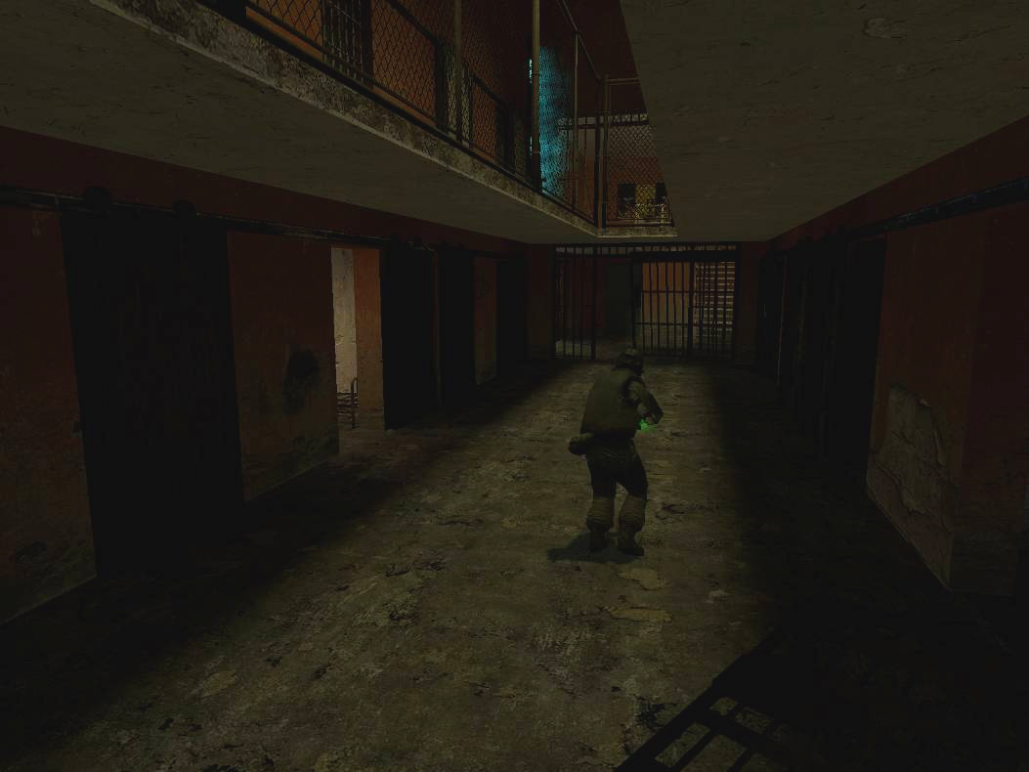
Fig. 3.3 – Since this is the first area in the level, there are plenty of shadows that the player can use to hide in.

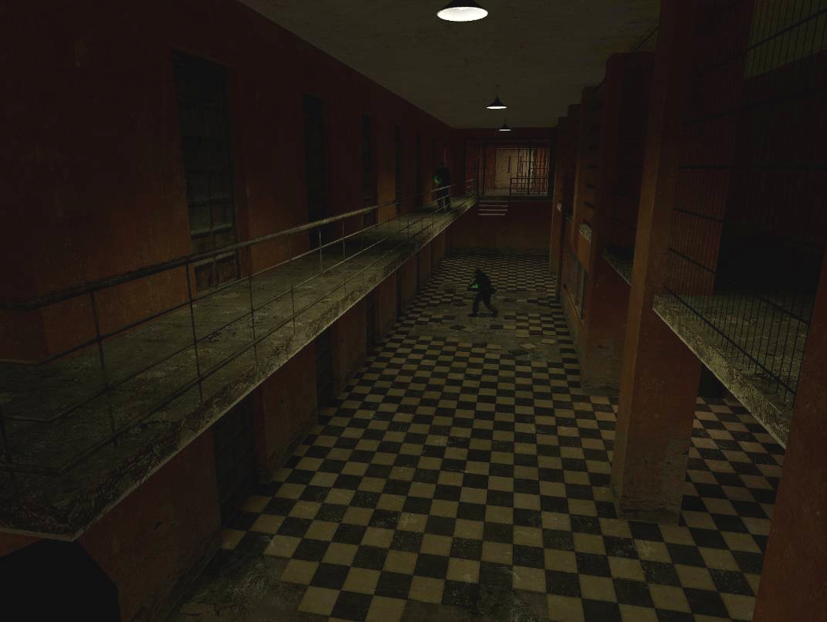
Fig. 3.4 – Cell Block 5. Since the level is relatively short, the difficulty ramps up quickly. In the second area, the player has to deal with multiple guards at once, and determine how to approach the situation.
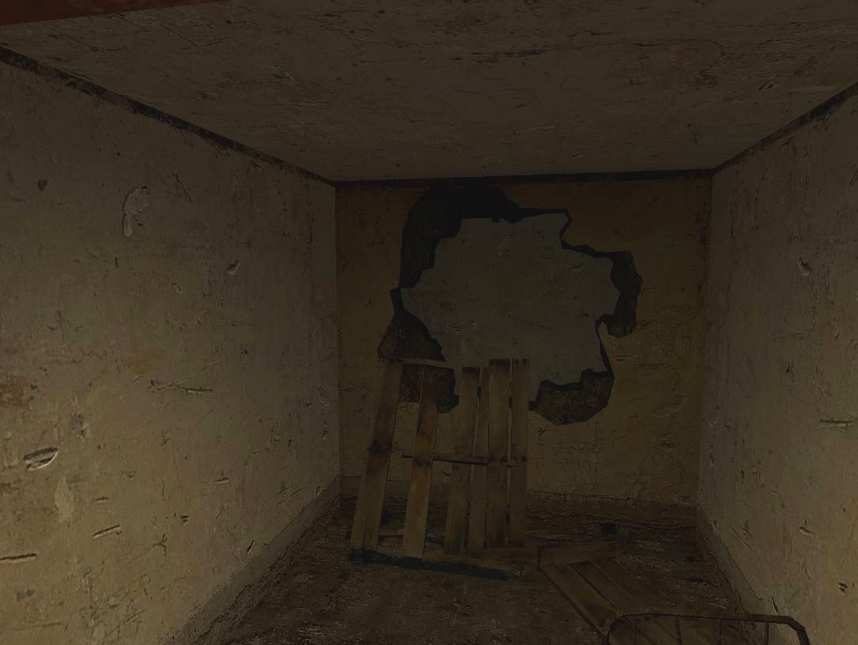
Fig. 3.5 – There are two paths between the two cell blocks, each one providing a slightly better position on the enemies in the next area.
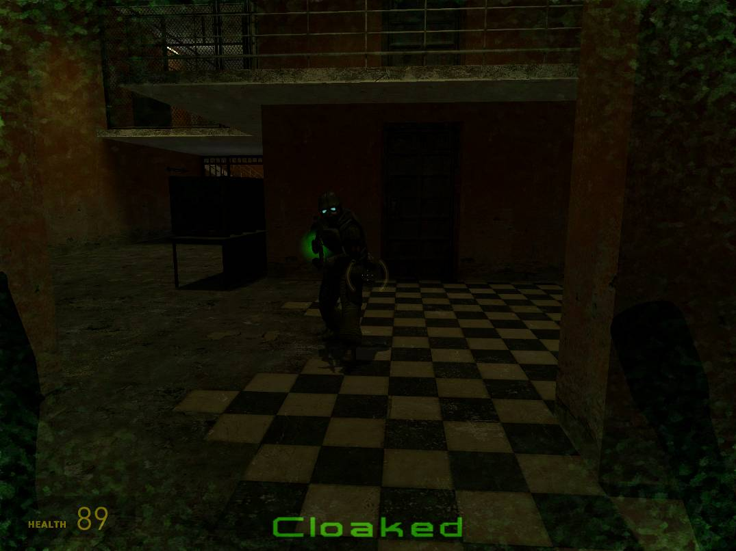
Fig. 3.6 – The “Cloaked” Screen Overlay; displays whenever the player is rendered invisible to enemy NPCs. Most stealth games have some type of light meter or visibility awareness/feedback, so this was my method of informing the player that they are (relatively) safe.

3:5:5:2 Prison Yard & Guard Hall
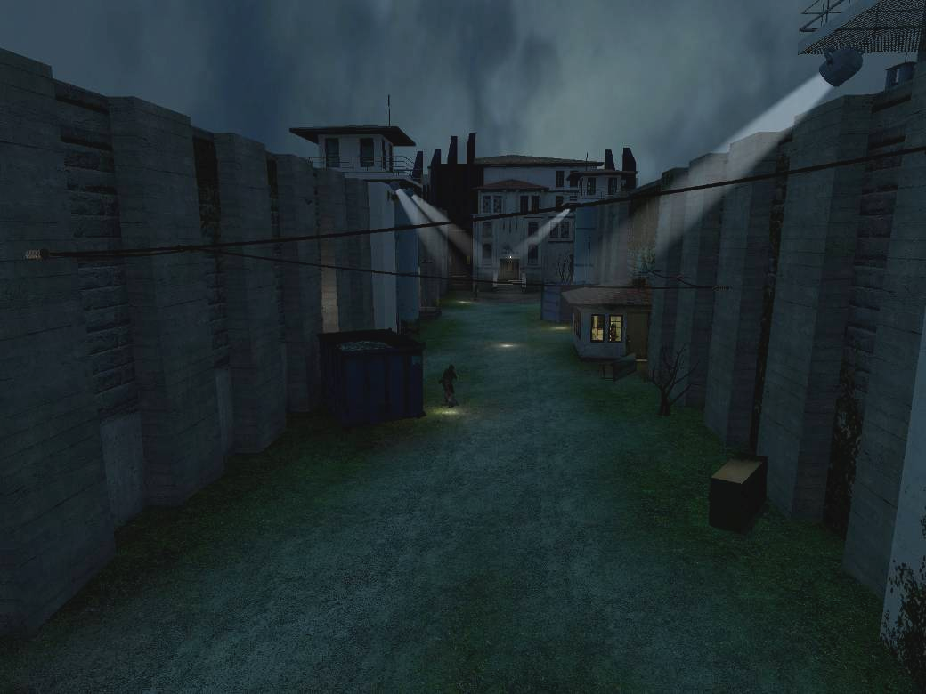
Fig. 3.7 – The Prison Yard – If the player is spotted in this area, an alarm is triggered, which causes (stealth) the guards in the area more “aware” (increases viewcones, distances, etc) or (action) guards and manhacks to appear and attack the player.
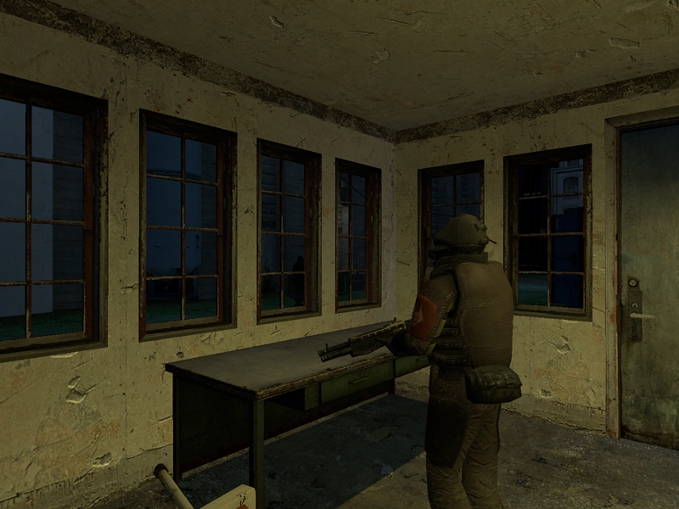
Fig. 3.8 – The stationary guard in the middle of the yard acts as a choke point for players attempting to stealthily move through the Prison Yard.

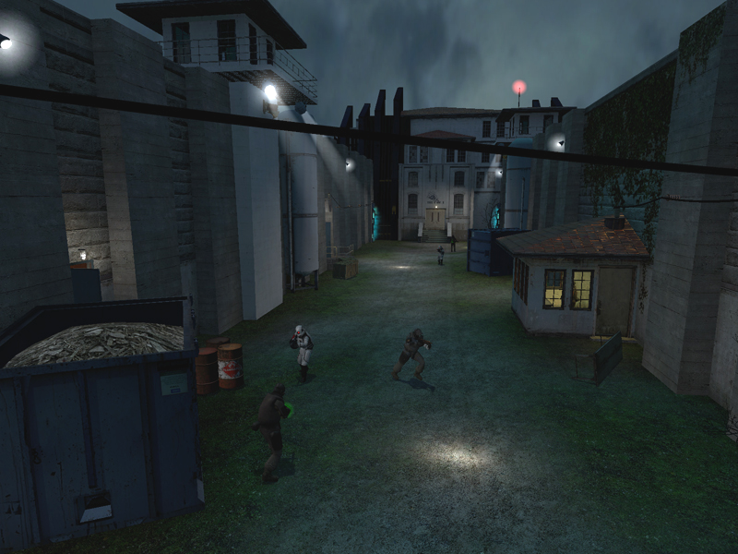
Fig. 3.9 – Setting of the alarm in the action version causes the area to go into lockdown. The alarm can drastically change the difficulty level of this area.
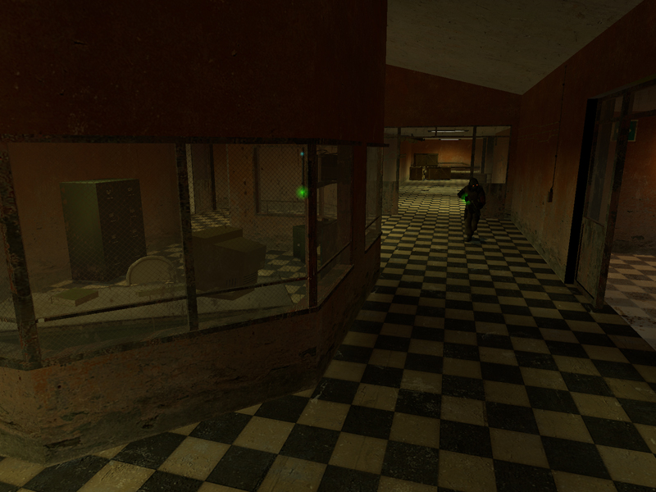
Fig. 3.10 – The Guard Hall area opens up only after the player has set up the alarm, so its possible that more skilled players may not see this area at all.

3:5:5:3 Entrance Hall & Lobby

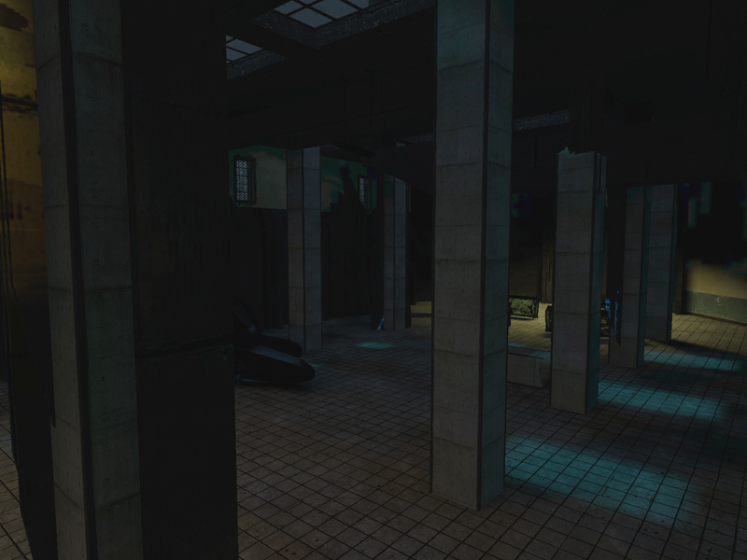
Fig. 3.11 – The Lobby area provides two unique experiences depending on the version played. The stealth version is a straightforward “shadow-hop” (moving safely from dark area to dark area) to the exit. The action version forgoes any semblance of stealth gameplay and instead goes out with a fast-paced ambush sequence.
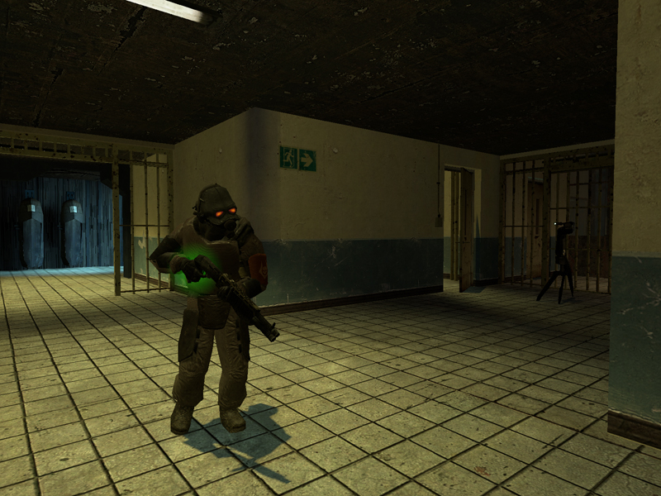
Fig. 3.12 – The Entrance Hall area provides a small rest area for players after the potentially harrowing experience in the Prison Yard.
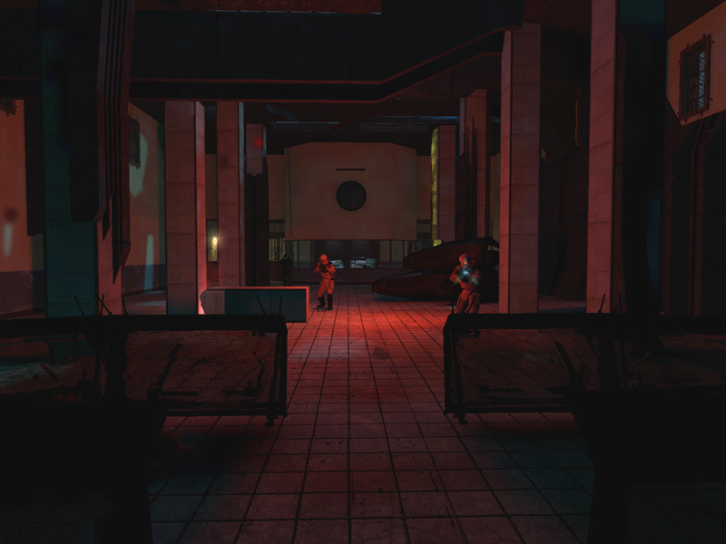
Fig. 3.13 – The ambush sequence from the action version of the map. After some tension building, the guards cut the lights and repel in from the ceiling skylights.

3:5:6 Rough Map
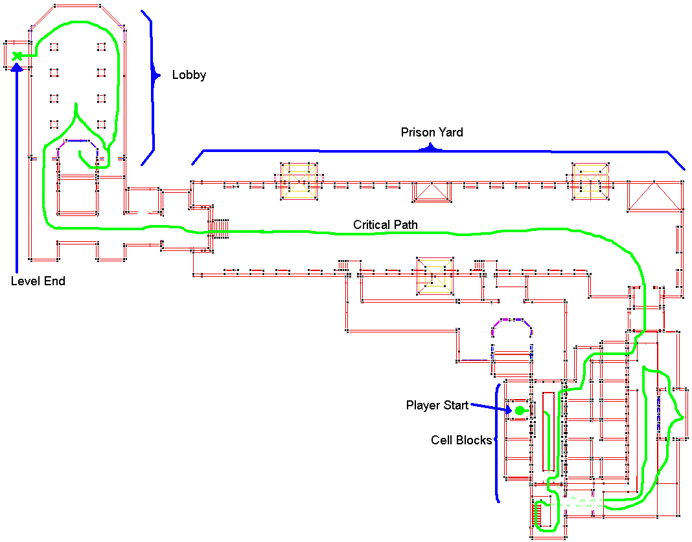
Fig. 3.14 – Rough Map of both level versions. The Critical path varies slightly between the two.
3:6 Survey Questions

General Questions
- Gender:
- Age:
- Discipline (Art/LD/Programming) (if applicable):
- Have you played a stealth game? If so, what is your opinion of the genre? If not, is there a particular reason?
- On a scale of 1-5, what do you think of stealth gameplay as a whole? Action gameplay? (1 = hate it, 5 = love it)
  - Stealth: 1 2 3 4 5
  - Action: 1 2 3 4 5
- What version(s) of the map did you play?: Action Stealth Both

Room-by-Room Walkthrough - For the version of the map that you played, describe your experiences in each area.
- Cell Blocks 4 & 5
  - Difficulty (1 = easy, 5 = difficult): 1 2 3 4 5
  - Overall Impressions of area (elaborate on answers if possible)
    - Enjoyed it
    - Enjoyed mostly, but…
    - Not bad but not great either
    - Disliked it, but had some good points…
    - Hated it
  - Other Comments
- Prison Yard & Guard Hall
  - Difficulty (1 = easy, 5 = difficult): 1 2 3 4 5
  - Overall Impressions of area (elaborate on answers if possible)
    - Enjoyed it
    - Enjoyed mostly, but…
    - Not bad but not great either
    - Disliked it, but had some good points…
    - Hated it
  - Other Comments
- Entrance Hall & Lobby
  - Difficulty (1 = easy, 5 = difficult): 1 2 3 4 5
  - Overall Impressions of area (elaborate on answers if possible)
    - Enjoyed it
    - Enjoyed mostly, but…
    - Not bad but not great either
    - Disliked it, but had some good points…
    - Hated it
  - Other Comments

Gameplay Questions
- Describe your impressions on the overall flow of the level (some points to think about are listed below)
  - Did areas flow together well/were you lost at any point?
  - Was there too much cover (did it get in the way) or did you need more?
- Describe your overall experience for the version of the map you played; Did you enjoy it? Was there anything about the level as a whole that stuck out to you?
- For players of the stealth version, was the implementation of the stealth mechanics sufficient/did it adversely effect the experience?
- List any additional comments/suggestions here.
4: Results and Analysis

4:1 Demographics
The survey asked playtesters to provide some basic demographic information in order to highlight any potential correlations between demographics of the playtesters and the data findings. In total, there were 10 playtesters, but each individual playthrough of a level counted as a separate test, so in total there were 14 responses (some played only one version, some played both versions). The demographics for these tests are not that surprising; the majority of playtesters were male, and all of the playtesters were under 30, which represents the typical gamer audience. Though the testers were able to choose which version they preferred to play, a third of the playtesters chose to play both.
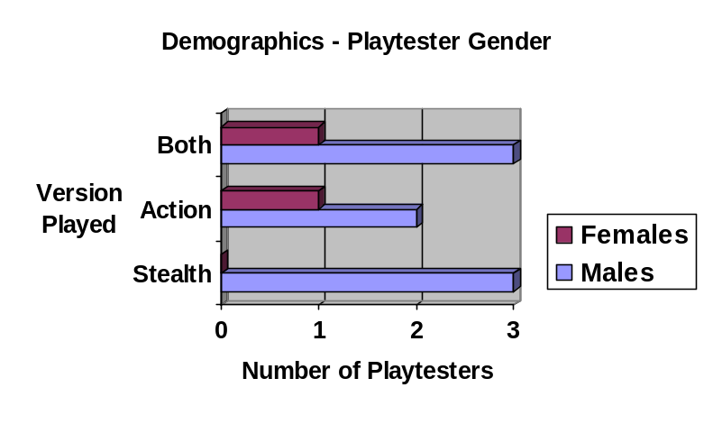
Fig. 4.1 – Player Gender Demographics
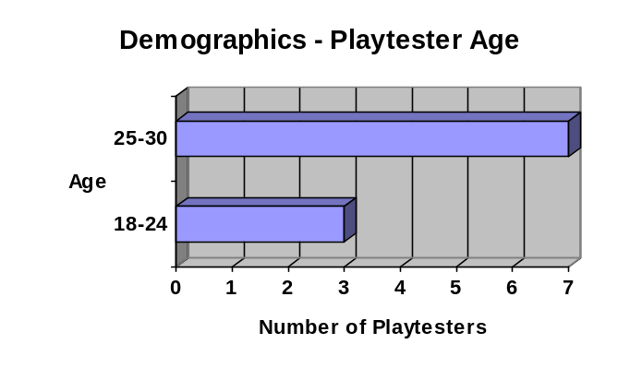
Fig. 4.2 – Player Age Demographics

4:2 Genre Ratings
In order to get a general feel for what the playtesters thought about each of the genres, the survey posed the following question to playtesters: “On a scale of 1-5, what do you think of stealth gameplay as a whole? Action gameplay? (1 = hate it, 5 = love it)” The results were, as expected, varied between the two genres; stealth gameplay got a slightly broader spectrum of ratings, while reactions toward action gameplay were generally positive. The mixed reaction to stealth gameplay is most likely due to the low tolerance for failure; players tend to get easily frustrated when playing stealth games,which can lead to an overall disdain for the genre.
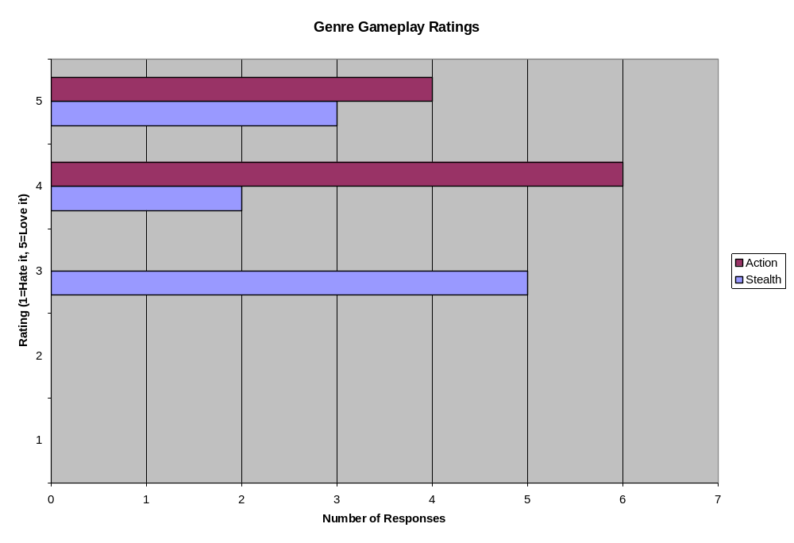
Fig. 4.3 – Genre Gameplay Ratings

4:3 Room-by-Room Analysis
Playtesters were asked to rate the difficulty and their overall experience for each of the three areas (Cell Blocks 4 &5, Prison Yard & Guard Hall, Entrance Hall & Lobby) in the version of the level they played. These ratings were useful for gauging the individual experiences of the playtesters and for determining if a single area proved frustrating to players. The overall experience question was not a simple 1-5 scale however, it was the multiple choice question below; this was done in order to get some basic feedback (by pressed-for-time playtesters, who could just choose their answer and move on) and get more extensive feedback if possible:

    - Overall Impressions of area (elaborate on answers if possible)
      - Enjoyed it
      - Enjoyed mostly, but…
      - Not bad but not great either
      - Disliked it, but had some good points…
      - Hated it

4:3:1 Cell Blocks 4 & 5 - Figures
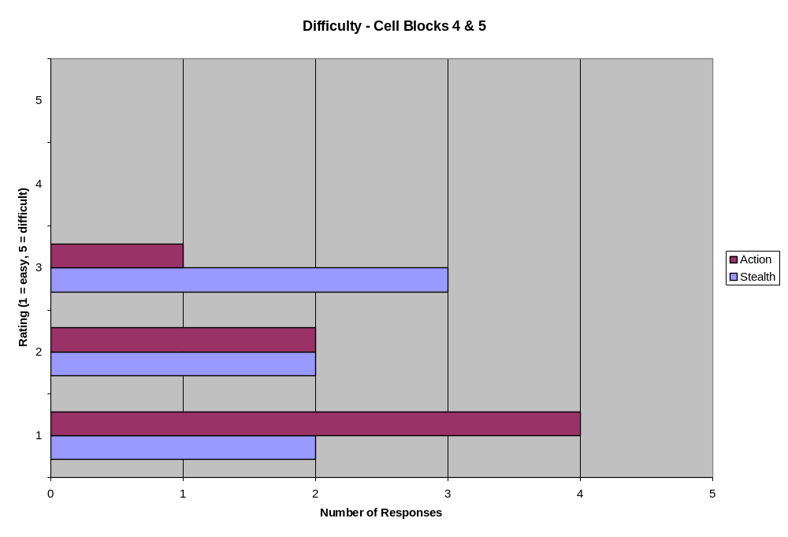
Fig. 4.4 – Difficulty Rating for Cell Blocks 4 & 5
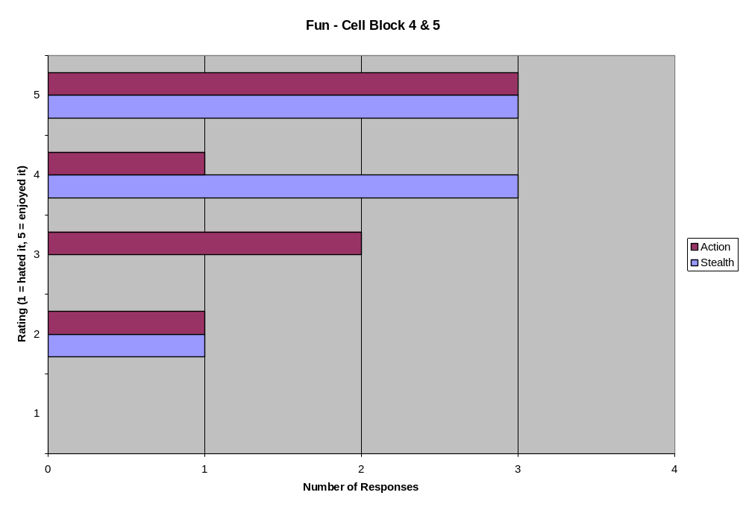
Fig. 4.5 – “Fun” Rating for Cell Blocks 4 & 5

4:3:2 Cell Blocks 4 & 5 – Analysis
The first area, Cell Blocks 4 & 5, was widely regarded as the easiest area of the level, and this was intentional. This area acted as a pseudo-tutorial, where the level introduced the player to the stealth mechanics. The difficulty ratings suggest that this was successful, since players generally found the area easy. The ratings for the stealth version of the level were a bit more widespread, ranging from easy to normal difficulty, though this is not surprising, since stealth gameplay has a steeper difficulty curve. Although this was not reflected in the ratings, some players also encountered some bugs with the stealth implementation during playtests: guards not returning to their patrol paths, stealth kill volumes suddenly disappearing when the player was trying to sneak up on a guard. Though these bugs were not large enough to hurt the overall experience or significantly increase the difficulty of the area, they were worth mentioning.
The overall experience / “fun” ratings for this area were generally good, although this is the first point at which one particular playtester’s ratings stick out. One playtester, who played both versions of the map, rated this area particularly low (2), while the majority of the ratings were higher. This playtester actually affects the averages in all areas of the level, and, while they were definitely in the minority, the response given was worth mentioning, since “fun” is relative. The comments from this playtester indicate that they could not determine when they were hidden or a method of completing the area without being detected. One other playtester made a similar comment in the next area (the Prison Yard) about not being able to tell when they were hidden. While there is a screen overlay that is applied when the player is in shadow, if the player has been spotted already, then this screen overlay will not show up (done to let the player know that the shadows are not a safe hiding place when they have been detected). Splinter Cell and Thief use a similar system (where soft cover effectiveness is reduced once the player has been spotted). However, since the shadow/invisibility volumes were essentially faked into a binary system (either hidden or not), and there are varying degrees of shadow in the actual level, which shadows hid the player and which did not was left up to the designer. This most likely is what caused confusion about which shadows were safe and which were not and resulted in lower ratings in both this instance and in the next area.
The differences between the two versions of this area were relatively minor; the action version had one more guard than the stealth version (removed from the stealth version since there was no way to sneak up on him), and the stealth version had stealth volumes in the darker corners of the level.

4:3:3 Cell Blocks 4 & 5 - Comments
Stealth Version
- Did a poor job of conveying what was considered to be hidden. Could not determine a method for completion without being detected. Crawl space useless since if you got the stationary guard, you couldn’t be hidden from patrolling guard.
- Hard to tell when stealth is “on”. Sometimes the overlay is up, and sometimes it just goes away for no apparent reason. Other than that, I thought it did a good job of introducing the core concept. Text needed to stay up longer.
- Good difficulty, knew where to go
- Bit easy
- Easy but might need more health for noobs
Action Version
- Played this version first. I tried to stealth-kill first guard, but he saw me right away as he was walking past the cell door even though I had not moved. Other than that, I felt clever for finding the passageway around which allowed me to sneak up on the stationary guard without alerting the patrolling one.
- Nice warmup
- Wasn’t a lot of ammo available for action players, which effects the next part of the level

4:3:4 Prison Yard & Guard Hall - Figures
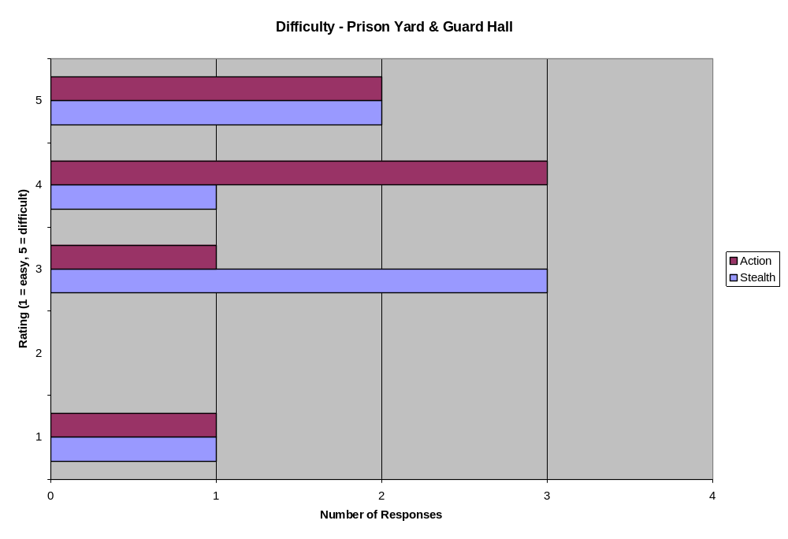
Fig. 4.6 – Difficulty Rating for Prison Yard & Guard Hall
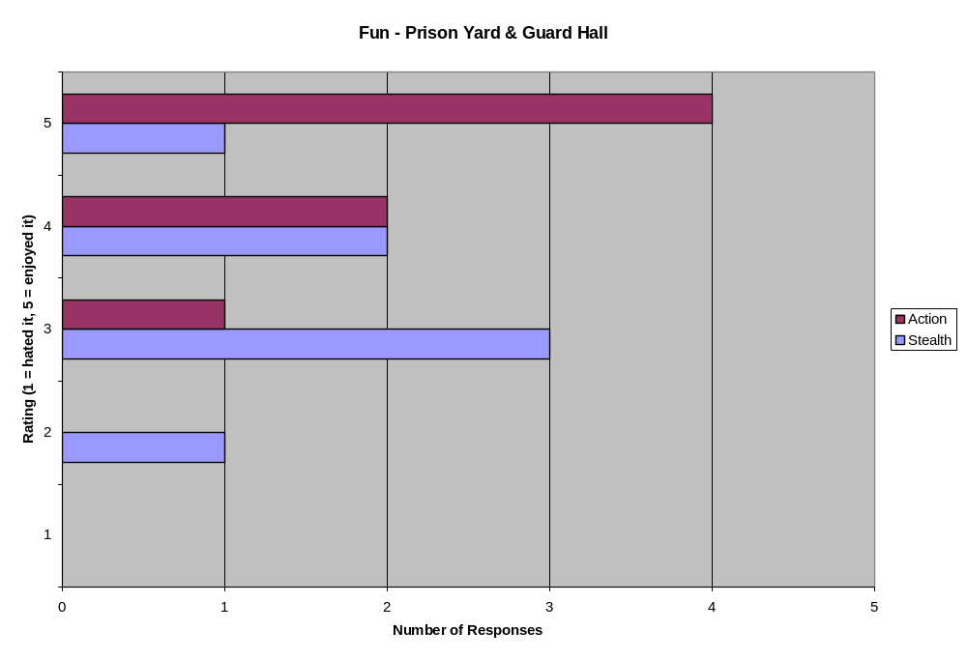
Fig. 4.7 – “Fun” Rating for Prison Yard & Guard Hall

4:3:5 Prison Yard & Guard Hall – Analysis
The Prison Yard area proved to be the most challenging area in both versions of the level, mainly due to the multiple ways in which the player could “fail” (set off the alarm). The alarm drastically changes the difficulty of the action version of the level, and only slightly increases the difficulty of the already challenging stealth version. The difficulty curve shape (a slightly skewed bell curve) was intentional, but the reasons for the difficulty spike in the Prison Yard were not. Players in the action version often found that they did not have enough ammo to survive the onslaught that occurs after setting off the alarm. Once again, one playtester’s (the same as for the previous area) response affects the curve; this individual was actually the only playtester who found both versions of the Prison Yard area to be easy.
The overall experience / “fun” ratings provided some unique results for each version of the map. The action version of the map, besides being difficult, was still entertaining to the playtesters, with the majority giving it a 5 out of 5 rating, and the rest being at least a 3 out of 5. The stealth ratings were more telling since they were more widespread. Slight bugs in the stealth implementation often caused guards to spot players when they believed they were safe or hidden (due to over-sensitive hearing on one of the guards). Players for both versions found that there was too little cover in the area. Unfortunately, this was an unavoidable side effect of implementation, since the searchlights in this area essentially use a long trigger volume that can “see” the player through solid cover. Instead of potentially making the player feel cheated (by being spotted through a piece of solid cover), cover was moved to the edges of the play area.
The text comments provided some slightly more detailed feedback. The frustration over the Prison Yard area and some of the stealth mechanics was a bit more blatant, but overall, the comments were still mostly positive. One particular stationary guard in the stealth version of the Yard essentially made it impossible for some players to make it through the area stealthily. The cover issue is also blatantly clear here as well, since two playtesters mention it, one of which actually quit at this point in the level. Two playtesters also had trouble with the critical path, particularly when the alarm went off. The variety of feedback and the distribution of the ratings leads to the conclusion that while some players enjoyed it, the stealth implementation detracted from the overall experience to most.

4:3:6 Prison Yard & Guard Hall – Comments
Stealth Version
- This one hurt me. I was hampered by not being able to tell when I was in stealth. Also had a hard time figuring out the radius of the spotlights. Is it possible to kill the stationary guard in the shack without him seeing you? I was trying to stealth kill every guard in the map, and he really, really hurt me. Twice.
- Too little cover in the Yard, little unsure what to do when alarm went off.
- Favorite area of the level. A lot of fun getting around the lights + guards.
- Buggy guy in shack. Don’t know where to go to shut off alarm.Confused about critical path most of the time
- Not enough cover. Quit at this point.
- Had to explore a bit before I found my way
Action Version
- Meh. Spot lights are easy to ignore and evade
- The manhacks kind of sucked, but other than that it was fun.
- Constantly having to switch weapons due to not having enough ammo wasn’t fun
- I made it through without alerting anyone. I rock.
- Not really hard, just a link hinky.
- Bit hard, wanted more ammo/hp
- Fun combat. Died once because of low ammo from previous area

4:3:7 Entrance Hall & Lobby - Figures
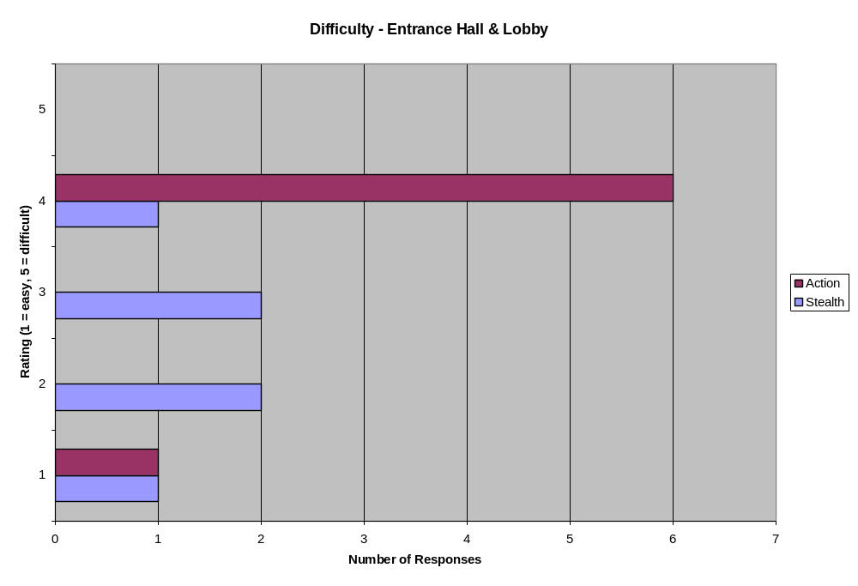
Fig. 4.8 – Difficulty Rating for Entrance Hall & Lobby
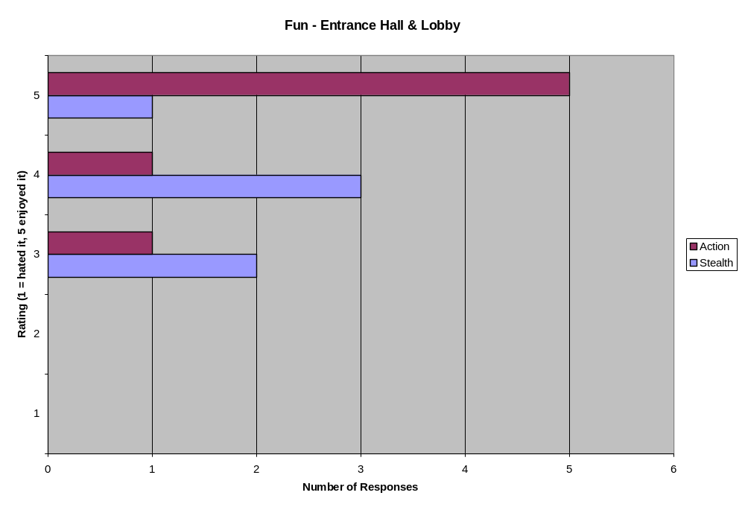
Fig. 4.9 – “Fun” Rating for Entrance Hall & Lobby

4:3:8 Entrance Hall & Lobby – Analysis
The final area of the map, the Entrance Hall & Lobby, serves as the climax for the action version of the map. As such, the difficulty increased a bit. Most playtesters found it rather difficult (except of course the odd-man-out playtester from before). The difference in implementation between the two versions of the map is most drastic in this area: the action version has the player ambushed by Combine forces while the stealth version simply has the player sneaking past a few more guards in the area. Therefore, the difficulty curves were decidedly different, with the stealth version being a bit more widespread depending on the player’s skill at stealth gameplay.
The overall experience / “fun” ratings for the Entrance Hall & Lobby were generally high. The action version of the level scored high among almost all of the playtesters. As mentioned earlier, the lobby sequence in the stealth version was not particularly climactic; this resulted in a broader spectrum of ratings. Creating an exciting climax using solely stealth gameplay is relatively difficult, especially if the player has little to no recourse upon discovery. As a result, the ratings for the stealth version of this area were not as high as the action versions.

4:3:9 Entrance Hall & Lobby - Comments
Stealth Version
- The hud informed when you were in stealth so just needed to sprint to shadows then the door.
- This part was really easy, maybe because I decided to stop trying to kill every guard I saw. I just snuck past the first one and ran for the exit.
- Too easy, just ran by the two guards in the area.
- Still liked it, but was less obvious what to do
- Door control needs to stand out more, still confused about where to go.
- Had to beat 2 ppl to death because it was difficult to watch pathing
Action Version
- For the action side, it was stupid since it was just fire fire fire; too much like lost coast.
- Missed the room with the health the first time and was locked into the main hall with little health. Fail. Found the room the second time. Did better.
- Good stuff. (x4)
4:3:7 Average Ratings - Figures
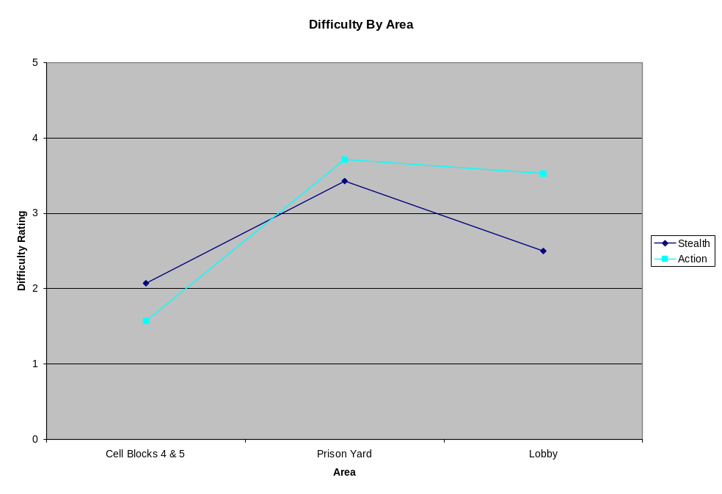
Fig. 4.10 – Average Difficulty by Area
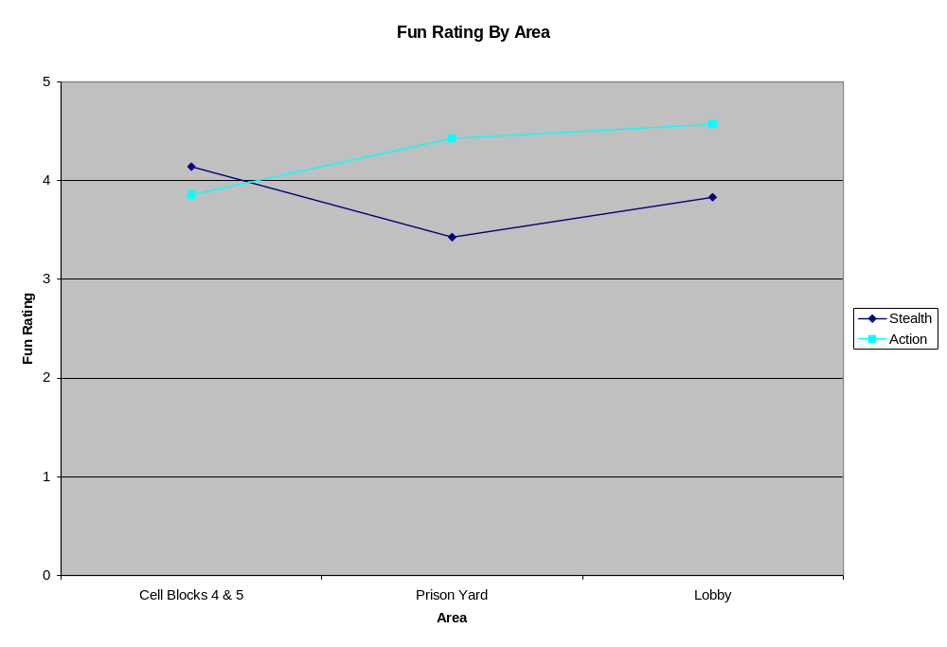
Fig. 4.11 – Average Fun Rating by Area

4:3:8 Average Ratings – Analysis
Figures 4.10 and 4.11 show the averages from the data presented in Figures 4.4-4.9. Figure 4.10 is the general difficulty curve of the levels themselves. Figure 4.11 is the overall “fun” rating (overall experience rating) of the levels. These ratings approximately match the expected target curves for each version of the level; the difficulty curve in particular turned out quite well, especially given the unintentional difficulty spike in the Prison Yard area. The gameplay / “fun” rating curves are lower than expected, particularly in the stealth version. The frustration over the Prison Yard area is quite clear given the dip in the middle of the curve. From the data collected, it seems as though there is a relationship between difficulty and “fun” ratings: with the stealth version, as difficulty increased (in the Prison Yard area), the “fun” rating went down. Strangely, in the action version, the opposite occurred and then leveled out; when the difficulty went up in the Prison Yard, the “fun” rating went up, and then went up again when the difficulty lowered slightly in the Lobby area. This data seems to support the conclusions made by Ed Byrne in “Game Level Design” that players want a challenge but they do not want to be frustrated by that challenge; there is a certain “sweet spot” where the challenge provides a great experience without annoying the player, and the Lobby area comes closest to accomplishing this.

4:4 Analysis Summary
The data collected from playtesters was a combination of objective and subjective data, with the testers giving each level ratings for both the difficulty and “fun” level, then elaborating on their ratings with written comments. In addition, there was some basic demographic data (to see if there was any age/gender correlations to genre preference, which there was not), some questions about the testers attitude towards the two genres and some questions about the general flow and implementation of stealth mechanics in the level(s) (see Section 3.6 for the exact questions asked and Appendix A for the survey results). The figures above show some of the various distributions of the objective data. Based on these figures alone, one could conclude that the project was a relative success, with players finding both levels “fun” to varying degrees. Though the objective data is valuable in its own right, the subjective feedback on the flow of the level and the overall experience is more telling. Also, based on the data collected, the playtesters varied in their gameplay preferences: all of the playtesters enjoyed action-oriented gameplay, but the ratings for stealth gameplay were a bit more varied, with some playtesters saying that they enjoyed stealth gameplay, and others giving it more middle-of-the-road rating. Strangely, there was no real correlation between the genre preferences and the level ratings; playtesters who played the stealth version but didn’t necessarily enjoy the genre generally rated the level well, while those who do enjoy the genre were varied in their ratings, ranging from 3 to 5.
Based purely on the objective feedback, almost all of the playtesters gave both versions of the level a “fun” rating of 3 or above (see Section 4:3 for the exact terminology of the question posed to playtesters). Using this type of scale allowed testers to put qualifiers on each of their ratings, which provides more constructive feedback than a simple 1-5 scale.
Surprisingly, it seems as though the action-focused playtesters who played the stealth version did not really have a problem with stealth itself, just the implementation of the stealth mechanics. While the comments often pointed out the flaws in the stealth implementation, the ratings themselves were generally high, implying that, if these bugs were fixed, the level might result in higher ratings. These results suggest that the implementation of stealth in an action level was, in this case, relatively successful, though further playtesting may have helped eliminate some of the gameplay problems. Most of the gameplay issues were relatively minor and easy to fix (more health and/or ammo would make the Prison Yard a bit easier), but the flaws in the stealth implementation would be a bit more difficult, and would require some more complex code fixes.
Some of the data collected also pointed to what some would call one of the flaws of stealth gameplay as a whole and to a mistake made during testing: whenever a guard discovers the player, there is natural reaction by many action (and, to a lesser degree, stealth) players to want to rush the enemy and (slowly) beat them into submission. This often led to the player taking a lot of damage, and not being able to survive the next time the enemy discovers them. Unfortunately, there was not enough time to introduce all of the playtesters to the stealth mechanics of the level (a planned mini-tutorial level introducing the stealth mechanics was cut). While the player is able to rush the enemy when discovered, the best course of action is to actually run away from the enemy, find cover, and wait for them to give up and go back on their patrol. This is an unusual mechanic and one that most players (both action and stealth) are not familiar with; retreating is not a common (or particularly attractive) method of beating a level and it seems counter intuitive. Even when notified that retreating was the best option, players still generally chose a frontal assault over a stealth approach. Another contributing factor that may have affected the playtesters actions was the fact that almost all of the playtesters had played Half-Life 2 before. Their prior experiences in Half-Life 2 most likely affected their playthroughs and how they approached each situation (by leading them to take a slightly more aggressive approach, and a tendency to look for the single, static path through the level).
In the end, the addition of stealth gameplay did not hinder the level building process; however, it did have a noticeable effect on one of the level’s areas, though this hindrance was mainly due to the implementation. The addition of the searchlights in the Prison Yard area was made primarily with stealth gameplay in mind. Searchlights, spotlights, and cameras in stealth games often serve as enemies with easily predictable paths and extremely limited viewcones. The implementation in the test level(s) unfortunately was flawed (the trigger did not require a clear line-of-sight in order to “see” the player), and actually created a design hurdle which had to be worked around. While this proved to have an adverse effect on the gameplay (cover had to be reduced and shifted closer to the walls), the overall gameplay of the level remained solid, and, the level could have been designed without the searchlights and retained most of its structure/flow.
Although this project showed that a single playspace could successfully be designed with both action and stealth gameplay in mind, in this case, some unique elements had to be taken into consideration. The level geometry between the two versions of the map was almost identical, but the lighting, item placement, enemy placement, and sequences/in-game events were very different. The actual time it took to make these changes was minimal, taking one week, on a project that took over 6 months to create. Though that seems like a lot of different material, some of the alterations made catered each individual level to the different playstyles. The differences in lighting was a relatively minor detail, since in the action version of the map, the presence of heavy shadow did not effect gameplay. The item placement changes were dependant on the player inventory/abilities: the action version required ammunition and more health and armor pickups than the stealth version, since, in the stealth version, the player only had one weapon and it did not require ammunition. Enemy placement and in-game events (specifically, what happens when the player triggers the alarm in the Yard and the Lobby sequence) were the two biggest differences between the levels. In fact, the number of standard, non-scripted event enemy NPCs was almost the same between the two levels (there was one more guard in the Cell Block 4 & 5 area in the action version of the level). Again, the reasons for these changes was primarily for gameplay balance; while the alarm in the Yard could have had the same consequences in both versions, the difficulty curve for the stealth version would spike tremendously, and it would be nearly impossible for stealth players to complete the level after triggering the alarm. The ambush sequence in the Lobby would also be almost impossible for stealth players to survive, and as a result, the stealth version of the map had a different Lobby sequence.
While the action version of the level had some basic stealth mechanics available, the level forced the player into action gameplay at certain points (in the Prison Yard, if the player is spotted, and in the Lobby area). While it is completely possible to combine the stealth mechanics of the stealth level with the action gameplay of the action level, the combination of the stealth volumes and ranged weapons is slightly unbalancing in this case, and the design (and the HL2 code base) would have to be tweaked further to compensate. Certain stealth games such as Thief and Splinter Cell manage to make the combination work, but the creators of those games had stealth gameplay in mind during development. In those games, the AI is able to handle situations where the player hides and attacks from afar. In base HL2, the AI is not programmed to handle such situations. In addition, with stealth volumes and ranged weapons, a single guard no longer poses a threat to the player. In the stealth version of the map, the goal was to force the player to try to avoid confrontation, and with ranged weaponry, the temptation (and ease) of simply attacking a lone guard (as opposed to sneaking around him) is too great. Since the majority of the bugs and difficulty encountered during development were spent trying to get the HL2 AI to act appropriately or trying to fake light sensitivity for various entities (getting shadow volumes in, searchlight implementation), it is reasonable to assume that trying to force an action engine to handle stealth gameplay after the initial development is no easy task.
When designing the action version of the level, most of the stealth tools Randy Smith discussed in his GDC presentation were taken into consideration, so when creating the stealth version of the level, a minimal amount of changes would need to be made. Heavy Shadows/Soft Cover and Static & Patrolling Enemies were probably the easiest to implement since soft cover has no real effect on gameplay in the action version and the static and patrolling enemies were used in both versions, since they add to the gameplay in either playstyle. As mentioned earlier, getting the NPCs to return to their patrol paths after they spotted the player was technical hurdle that required some extensive research and scripting. Hard Cover proved to cause some issues in implementation, since, as mentioned before, the searchlights in the Yard area were able to see through solid cover, and as many of the survey results showed, this area was in need of more cover in both versions. Connectivity was probably the most difficult tool to use effectively in the levels, since it can often cause confusion about what the critical path is. The Cell Block 4 & 5 area was probably the most interconnected area in the level(s), with three potential paths between the two Cell Blocks. While some playtesters liked exploring and finding the secret passageway in one of the cells, many were confused when they had to backtrack slightly in order to progress to the next area. Some playtesters encountered a similar issue in the Prison Yard area. While the Connectivity of the playspace was minimal, the difficulty playtesters encountered may have been because Half-Life 2 is a relatively linear game, and existing preconceptions about the nature of HL2 levels may have affected their tests.
While there was some extra work needed in the development of the action level alone, it was relatively minimal. The considerations made for stealth gameplay did not adversely effect the development process as a whole. It is also important to consider the fact that, while the stealth gameplay implementation was not perfect, it still created an entertaining experience among the playtesters overall. This implies that the addition of stealth gameplay into the level building process of an action game can be successful, as long as the engine used can handle both play styles. The majority of the development time for the stealth version of the level involved the implementation of stealth gameplay elements in an engine not originally developed to support the stealth style.
5: Conclusion & Further Study

5:1 Conclusion
This study attempted to find a common ground between two somewhat polarized gameplay styles: stealth and action. While the considerations that go into the design process for a stealth game and an action game usually differ greatly, there is a common ground between the two. In order to test the proposed theory, this project required some extensive scripting in the Half-Life 2 engine to allow it to handle a basic form of stealth gameplay, and subsequently, the creation of a map that could handle both the stealth and shooter play styles. The survey results from the playtesters and the positive responses from both test groups (action gamers and stealth gamers) showed that a single playspace could be used effectively for both styles. While generally the stealth level scored lower than the action level, this was primarily due to the numerous bugs present in the stealth implementation. Although these bugs may have adversely affected the playtesters individual experiences, the information gathered from the playtests is still relevant, since players still generally enjoyed the stealth level. Also, not all playtesters encountered the same bugs. If these bugs had been fixed, presumably, the average ratings for the stealth level would rise, and the ratings from the stealth version would be closer to those of the action version of the map.
While stealth and action gameplay often provide uniquely different experiences for players, the differences between the underlying designs may not be that extensive. As mentioned earlier, there are numerous tools that both gameplay styles use. Stealth and action gameplay are distinctly different on the surface, but when it comes to designing a single playspace to handle both styles, there are certain elements that need to be taken into consideration. The key concepts Ed Byrne presents in “Game Level Design” (Section 2:3) act as a solid foundation for both gameplay styles, and the design tools Randy Smith presents in his GDC ’06 presentation (Section 2:2) were essential in creating an entertaining stealth experience. The combination of these two design theories resulted in two successful level designs; one action-focused, one stealth-focused. Since stealth gameplay is the more fragile of the two gameplay styles, it had a more profound effect on the initial design process for this project. While overall this proved to be a successful design method, there were certain points during the development of the stealth version where rooms or sequences were repurposed or changed completely. The reasons for these changes were primarily due to the way in which stealth gameplay was implemented in this instance (no ranged weaponry); if a more flexible stealth gameplay model were used, presumably the changes needed would not be as extensive.

5:2 Further Study
Recently, there has been an increased push in the industry to merge action and stealth gameplay into one experience, and to draw players who may have a preference towards one gameplay style towards the other. Recent and upcoming games like Hitman: Blood Money (IO Interactive 2006), Assassin’s Creed (Ubisoft 2007) and Splinter Cell: Conviction (Ubisoft) are drawing action gamers into the world of slower, tension-heavy stealth gameplay while simultaneously drawing stealth gamers into fast-paced, visceral action gameplay. All of these games focus heavily on “social stealth,” which brings stealth players out of the shadowy corners and into crowded city streets. If this type of stealth gameplay manages to provide a satisfying experience for both camps, then basic level design methodology might change yet again.
The action version of the level used in this project is an excellent example of this trend. While the focus was on the action gameplay, there was potential there for some solid stealth gameplay as well; many playtesters used the stealth kill mechanic when they could. The stealth elements of the action level were relatively simple, but a direct combination of the two levels (stealth mechanics from stealth level integrated into the action level) would create an experience akin to Splinter Cell. As mentioned earlier, some design changes would be necessary in order to get the best gameplay possible out of the level. Even so, this presents some unique questions that could be topics for further research: if an action level from an action game can be made into a stealth level, then isn’t it possible that an existing, proven action level design could be retrofitted to accommodate stealth gameplay? Or vice versa? Changing up the gameplay style used in a particular game space or level has the potential to extend the life of existing playspaces, and even expose them to different audiences. Some additional ideas for future research might include the conversion of existing action or stealth level designs to the opposing gameplay style and studying whether these playspaces hold up, or what changes would be needed in order to make it an effective or fun design.

References
Acquire; “Tenchu: Silent Assassins”; PlayStation Game, 1998. Activision.

Bryne, Ed. 2006. Game Level Design. Charles River Media, 2006.

Cut Corner Company Productions; “Weekday Warrior”; Half-Life 2 Mod, 2006. The Guildhall at SMU.

Eidetic; “Syphon Filter”; PlayStation Game, 1999. 989 Studios.

IO Interactive; “Hitman: Codename 47”; PC Game, 2000. Eidos.

IO Interactive; “Hitman: Blood Money”; PC Game, 2006. Eidos.

Konami; “Metal Gear”; MSX2 Game, 1987. Konami.

Konami; “Metal Gear Solid”; PlayStation Game, 1998. Konami.

Looking Glass Studios; “Thief: The Dark Project”; PC Game, 1998. Eidos.

Smith, Randy. 2006. Level-Building for Stealth Games. Presentation given at Game Developers Conference, March 20-24, in San Francisco, California. Powerpoint & Text Primer available at <http://www.roningamedeveloper.com/Materials.html>

“Stealth game”. Wikipedia, The Free Encyclopedia. 7 June 2007.
<http://en.wikipedia.org/wiki/Stealth_game>

Ubisoft Montreal; “Assassin’s Creed”; Xbox 360 Game, 2007. Ubisoft.

Ubisoft Montreal; “Tom Clancy’s Splinter Cell”; Xbox Game, 2002. Ubisoft.

Ubisoft Montreal; “Tom Clancy’s Splinter Cell: Pandora Tomorrow”; Xbox Game, 2004. Ubisoft.

Ubisoft Montreal; “Tom Clancy’s Splinter Cell: Conviction”; Xbox 360 Game, 2008. Ubisoft.

Valve; “Half-Life 2”; PC Game, 2004. Valve.

Valve; “Half-Life 2: Episode 2”; PC Game, 2007. Valve.

Appendix A

Completed Surveys - Digital

General Questions
- Gender: Male
- Age: 25
- Discipline (Art/LD/Programming) (if applicable): Programming
- Have you played a stealth game? If so, what is your opinion of the genre? If not, is there a particular reason? Tenchu; Metal Gear Solid
I’m pretty bad at stealth games. I’m rather impatient

- On a scale of 1-5, what do you think of stealth gameplay as a whole? Action gameplay? (1 = hate it, 5 = love it)
  - Stealth: 1 2 3 4 5
  - Action: 1 2 3 4 5
- What version(s) of the map did you play?: Action Stealth Both

Room-by-Room Walkthrough - For the version of the map that you played, describe your experiences in each area.
- Cell Blocks 4 & 5
  - Difficulty (1 = easy, 5 = difficult): 1 2 3 4 5
  - Overall Impressions of area (elaborate on answers if possible)
    - Enjoyed it
    - Enjoyed mostly, but…
    - Not bad but not great either
    - Disliked it, but had some good points…
    - Hated it
  - Other Comments
Did a poor job of conveying what was considered to be hidden. Could not determine a method for completion without being detected. Crawl space useless since if you got the stationary guard, you couldn’t be hidden from the patrolling guard

- Prison Yard & Guard Hall
  - Difficulty (1 = easy, 5 = difficult): 1 2 3 4 5
  - Overall Impressions of area (elaborate on answers if possible)
    - Enjoyed it
    - Enjoyed mostly, but…
    - Not bad but not great either
    - Disliked it, but had some good points…
    - Hated it
  - Other Comments
Meh. Spot lights are easy to ignore and evade.

- Entrance Hall & Lobby
  - Difficulty (1 = easy, 5 = difficult): 1 2 3 4 5
  - Overall Impressions of area (elaborate on answers if possible)
    - Enjoyed it
    - Enjoyed mostly, but…
    - Not bad but not great either
    - Disliked it, but had some good points…
    - Hated it
  - Other Comments
Just needed to sprint when his back was turned, no stealth involved. Came back around and threw the turret. For the Action side it was stupid since it was just fire fire fire; too much like lost coast.
For the stealth, the hud informed when you were in stealth so just needed to sprint to shadows then the door.

Gameplay Questions

- Describe your impressions on the overall flow of the level (some points to think about are listed below)
  - Did areas flow together well/were you lost at any point?
Hard to tell when a door could be opened from a distance. Didn’t know of some side areas in the yard.
  - Was there too much cover (did it get in the way) or did you need more?
In the final fight on the action side there wasn’t enough cover. It just was stupid. Otherwise, you did your best to stealth them or just beat the crap out of them.

- Describe your overall experience for the version of the map you played; Did you enjoy it? Was there anything about the level as a whole that stuck out to you?
Dark areas did not equate to being cloaked. Outside in the yard too much was visible so you never were really cloaked. Most encounters could not be sheathed. Sprint should have been removed.

- For players of the stealth version, was the implementation of the stealth mechanics sufficient/did it adversely effect the experience?
It blurred my side views and made it hard to make out details. FOV should have been wider. Most of the level was dark but the player wasn’t cloaked.

Additional Comments
- List any additional comments/suggestions here.

  - Increase FOV
  - Make the areas were one is cloaked more apparent from the rest of the environment
  - Replace HUD overlay for stealth with something less detail; its distracting to the eyes when it flickers from the background

General Questions
- Gender: Female
- Age: 30
- Discipline (Art/LD/Programming) (if applicable): LD
- Have you played a stealth game? If so, what is your opinion of the genre? If not, is there a particular reason?
Do the Thieves missions in Oblivion count? Other than that, there was MGS2 and the stealth portions of Beyond Good and Evil. I like stealth missions as a break during action games. My personal playstyle is more run and gun.

- On a scale of 1-5, what do you think of stealth gameplay as a whole? Action gameplay? (1 = hate it, 5 = love it)
  - Stealth: 1 2 3 4 5
  - Action: 1 2 3 4 5
- What version(s) of the map did you play?: Action Stealth Both

Room-by-Room Walkthrough - For the version of the map that you played, describe your experiences in each area.
- Cell Blocks 4 & 5 [STEALTH]
  - Difficulty (1 = easy, 5 = difficult): 1 2 3 4 5
  - Overall Impressions of area (elaborate on answers if possible)
    - Enjoyed it
    - Enjoyed mostly, but…
    - Not bad but not great either
    - Disliked it, but had some good points…
    - Hated it
  - Other Comments
It’s hard to tell when stealth is “on”. Sometimes the overlay is up, and sometimes it just goes away for no apparent reason. Other than that, I thought it did a good job of introducing the core concept. Text needed to stay up longer.

- Cell Blocks 4 & 5 [ACTION]
  - Difficulty (1 = easy, 5 = difficult): 1 2 3 4 5
  - Overall Impressions of area (elaborate on answers if possible)
    - Enjoyed it
    - Enjoyed mostly, but…
    - Not bad but not great either
    - Disliked it, but had some good points…
    - Hated it
  - Other Comments
Played this version first. I tried to stealth-kill the first guard, but he saw me right away as he was walking past the cell door even though I had not moved. Other than that, I felt clever for finding the passageway around which allowed me to sneak up on the stationary guard without alerting the patrolling one.

- Prison Yard & Guard Hall [STEALTH]
  - Difficulty (1 = easy, 5 = difficult): 1 2 3 4 5
  - Overall Impressions of area (elaborate on answers if possible)
    - Enjoyed it
    - Enjoyed mostly, but…
    - Not bad but not great either
    - Disliked it, but had some good points…
    - Hated it
  - Other Comments
This one hurt me. I was hampered by not being able to tell when I was in stealth (see overlay remark above). Also had a hard time figuring out the radius of the spotlights. Is it possible to kill the stationary guard in the shack without him seeing you? I was trying to stealth kill every guard in the map, and he really, really hurt me. Twice.
I ran into a bug or something with the patrolling guard in the Guard hallway. I successfully snuck up behind him and hit him. Instead of dying, he looked around, saw me, and went aggro. I had to beat him down with my mighty Baton-O-Death.

In this area and for the rest of the game, the ambient sound levels were obnoxious. I was mostly relying on footstep sounds to tell where the guards were but had a hard time hearing them over the sirens, helicopters, gunfire, random glass breaking sound, rockets, etc. Even indoors, it sounded like the same volume as in the yard.

- Prison Yard & Guard Hall [ACTION]
  - Difficulty (1 = easy, 5 = difficult): 1 2 3 4 5
  - Overall Impressions of area (elaborate on answers if possible)
    - Enjoyed it
    - Enjoyed mostly, but…
    - Not bad but not great either
    - Disliked it, but had some good points…
    - Hated it
  - Other Comments
The manhacks kind of sucked, but other than that it was fun.

- Entrance Hall & Lobby [STEALTH]
  - Difficulty (1 = easy, 5 = difficult): 1 2 3 4 5
  - Overall Impressions of area (elaborate on answers if possible)
    - Enjoyed it
    - Enjoyed mostly, but…
    - Not bad but not great either
    - Disliked it, but had some good points…
    - Hated it
  - Other Comments
This part was really easy, maybe because I decided to stop trying to kill every guard I saw. I just snuck past the first one and ran for the exit.

- Entrance Hall & Lobby [ACTION]
  - Difficulty (1 = easy, 5 = difficult): 1 2 3 4 5
  - Overall Impressions of area (elaborate on answers if possible)
    - Enjoyed it
    - Enjoyed mostly, but…
    - Not bad but not great either
    - Disliked it, but had some good points…
    - Hated it
  - Other Comments
Missed the room with the health the first time and was locked into the main hall with little health. Fail. Found the room the second time. Also saw the extra guards this time and took care of them from the booth. Did better. As a side note: are you allergic to health?

Gameplay Questions

- Describe your impressions on the overall flow of the level (some points to think about are listed below)
  - Did areas flow together well/were you lost at any point?
I was never really lost. I played the action version before the stealth one, so this probably helped. In the stealth version, I was a lot more careful and took a slightly different route.

  - Was there too much cover (did it get in the way) or did you need more?
The table in the prison yard (near the shack) was annoying. I kept getting hung up on it, and the stationary guard saw me anyways. The crates on the left of the yard by the hallway door were nice.

- Describe your overall experience for the version of the map you played; Did you enjoy it? Was there anything about the level as a whole that stuck out to you?
[ACTION] I liked this one the best, mostly because I had the choice to stealth or gun it. It was fun to try and kill as many guards as possible while stealthed, and I felt safer knowing that a screw up just meant I was going to gun it for a while. Less anxiety on the whole. Manhacks still suck. The prison yard stuck out the most. It was, visually, the best area, and there were lots of moving, shiny things.

[STEALTH] Going back to the overlay issue. It was really hard to tell what would alert the guards and when I was stealthed. Would they hear me run up behind them? Could they see me through objects? The overlay was confusing because I kept panicking when it went off, thinking that a guard had found me. It was nice that you could run away from some of them and they would forget you.

- For players of the stealth version, was the implementation of the stealth mechanics sufficient/did it adversely effect the experience?
It was fun in a way, but I preferred being able to choose on the fly whether to stealth or gun. I think making it more apparent where guards are and what actions alert them would have helped a lot. Especially when they were facing me, I could never tell how far away I needed to be to not be seen. I ended up hiding behind things and listening for their footsteps to tell when they had turned back around.

Additional Comments
- List any additional comments/suggestions here.
Health is your friend…

General Questions
- Gender: Male
- Age: 24
- Discipline (Art/LD/Programming) (if applicable): LD
Have you played a stealth game? If so, what is your opinion of the genre? If not, is there a particular reason?

- On a scale of 1-5, what do you think of stealth gameplay as a whole? Action gameplay? (1 = hate it, 5 = love it)
  - Stealth: 1 2 3 4 5
  - Action: 1 2 3 4 5
- What version(s) of the map did you play?: Action Stealth Both

Room-by-Room Walkthrough - For the version of the map that you played, describe your experiences in each area.
- Cell Blocks 4 & 5 [Stealth]
  - Difficulty (1 = easy, 5 = difficult): 1 2 3 4 5
  - Overall Impressions of area (elaborate on answers if possible)
    - Enjoyed it
    - Enjoyed mostly, but…
    - Not bad but not great either
    - Disliked it, but had some good points…
    - Hated it
  - Other Comments
- Cell Blocks 4 & 5 [Action]
  - Difficulty (1 = easy, 5 = difficult): 1 2 3 4 5
  - Overall Impressions of area (elaborate on answers if possible)
    - Enjoyed it
    - Enjoyed mostly, but…
    - Not bad but not great either
    - Disliked it, but had some good points…
    - Hated it
  - Other Comments

- Prison Yard & Guard Hall [Stealth]
  - Difficulty (1 = easy, 5 = difficult): 1 2 3 4 5
  - Overall Impressions of area (elaborate on answers if possible)
    - Enjoyed it
    - Enjoyed mostly, but…
    - Not bad but not great either
    - Disliked it, but had some good points…
    - Hated it
  - Other Comments
Too little cover in the Yard, little unsure what to do when alarm went off.
- Prison Yard & Guard Hall [Action]
  - Difficulty (1 = easy, 5 = difficult): 1 2 3 4 5
  - Overall Impressions of area (elaborate on answers if possible)
    - Enjoyed it
    - Enjoyed mostly, but…
    - Not bad but not great either
    - Disliked it, but had some good points…
    - Hated it
  - Other Comments
Constantly having to switch weapons due to not having enough ammo wasn’t fun.

- Entrance Hall & Lobby [Stealth]
  - Difficulty (1 = easy, 5 = difficult): 1 2 3 4 5
  - Overall Impressions of area (elaborate on answers if possible)
    - Enjoyed it
    - Enjoyed mostly, but…
    - Not bad but not great either
    - Disliked it, but had some good points…
    - Hated it
  - Other Comments
Too easy, just ran by the two guards in the area

- Entrance Hall & Lobby [Action]
  - Difficulty (1 = easy, 5 = difficult): 1 2 3 4 5
  - Overall Impressions of area (elaborate on answers if possible)
    - Enjoyed it
    - Enjoyed mostly, but…
    - Not bad but not great either
    - Disliked it, but had some good points…
    - Hated it
  - Other Comments
Good stuff.

Gameplay Questions

- Describe your impressions on the overall flow of the level (some points to think about are listed below)
  - Did areas flow together well/were you lost at any point?
  - Was there too much cover (did it get in the way) or did you need more?
[Stealth] – Got a little lost/unsure what to do once alarm went off in Yard area. Otherwise, flow was pretty straight forward. Could have used a little more cover in the Yard as well, everywhere else was fine.

[Action] – Same issue with alarm and cover in Yard area.

- Describe your overall experience for the version of the map you played; Did you enjoy it? Was there anything about the level as a whole that stuck out to you?
[Stealth] – Neat to sneak around in this engine. Only sticking point was the Yard, as mentioned earlier.

[Action] – Triggering the alarm in the Yard increased difficulty but got my blood pumping. Good ending with the ambush.
- For players of the stealth version, was the implementation of the stealth mechanics sufficient/did it adversely effect the experience?
Guards were kinda buggy in the Yard area, one in the shack always caught me. Unsure what exactly “cloaked” meant that I could do/not do.

Additional Comments
- List any additional comments/suggestions here.

Completed Surveys – Scans


