Duality: Prison Break
Half-Life 2
Document Date: 10/13/07

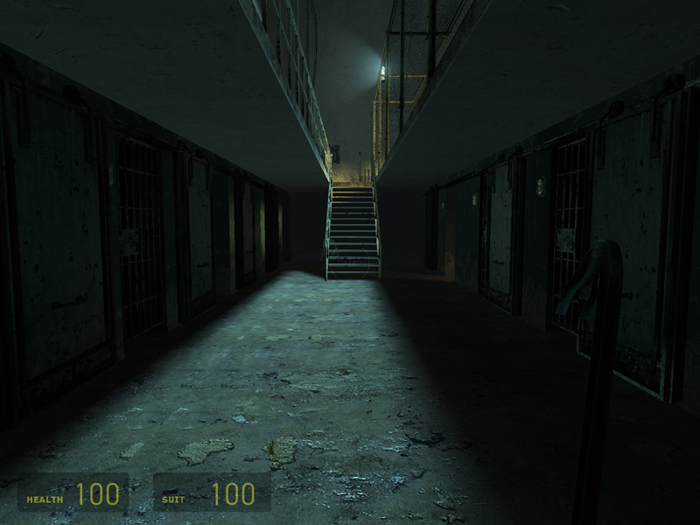

Designer: Steve Baroski
Intended Level Delivery Date: 2/26/08

Table of Contents
Revision Notes 4
Quick Summary 5
Gameplay Overview 5
Objective Summary 5
Technical Overview 5
Campaign 5
Mission Location 5
Mission Difficulty (1-5) 6
Mission Metrics 6
Technical Details 7
Level Atmosphere/Mood 7
Story 7
Major Areas/Visual Themes 8
Area A: Cell Blocks 4 & 5 8
Area B: Prison Yard 12
Area C, E: Prison Administration 15
Area D: Lobby 16
Map Objectives 18
Challenge Highlights 18
Combat 18
Stealth 19
Puzzles 19
Conversation 19
Boss Battles 19
Wow Moments 19
Actors 20
Player 20
Key Actors 20
Manhacks 20
Combine-S (Nova Prospekt) 20
Combine Elite 20
Floor Turret 20
(Tripod) Turret 20
Supporting Actors 21
Key Assets 21
User Interface 21
Gameplay Details 22
Gameplay Mechanics 22
Level Progression Chart 23
Level Thumbnail 24
Walkthrough/Detailed Map Description 25
Area A: Cell Blocks Map 25
Area A1: Cell Block 4 Walkthrough 26
Area A2: Guard Station Walkthrough 26
Area A3: Cell Block 5 Walkthrough 26
Area A4: Security Checkpoint Walkthrough 26
Area B: Prison Yard Map 27
Area B1: Prison Yard Walkthrough 28
Area B2: Barracks Walkthrough 28
Area C/E: Administration Building Map 29
Area C1: Administration Building Offices Walkthrough 30
Area C2: Administration Building Hall/Lounge Walkthrough 30
Area D: Lobby Map 31
Area D: Lobby Walkthrough 32
Area E1: Administration Building Gate Control Walkthrough 33

Revision Notes
10/13/07 – Initial version of document

Quick Summary
The player, Gordon Freeman, has been captured by Combine forces and sent to Nova Sedlo Prison. Shortly after arriving at the prison, Resistance forces launch an attack on the prison, and manage to inadvertently free Freeman from his cell. Equipped only with a crowbar, the player must escape the prison, and if possible, find a way to help the Resistance forces outside the prison walls.

Gameplay Overview
Duality: Prison Break is the “action” version of a level created to handle both action and stealth gameplay styles. The player is thrown into prison and must fight his way out.

While Prison Break focuses on twitch shooter gameplay, there are also some elements of stealth gameplay present, but they are optional. Only one mechanic, the ability to use the crowbar for a 1-hit kill sneak attack (when the player is behind an enemy), is used across the entire level and it provides the player with a method of quickly eliminating guards.

Objective Summary
- Survive:
  - Do not lose all Health.
- Escape Nova Sedlo Prison.

Technical Overview

Campaign
  - This is a stand-alone mission for Half-Life 2. Gordon Freeman – the player – has been captured and taken to Nova Sedlo prison. Shortly after arriving, the Resistance stages an attack on the prison in attempt to free Gordon. During the assault, a stray rocket hits the cell in which Freeman is imprisoned, and causes the area to collapse, sending Freeman into the old area of the prison. Equipped only with a crowbar, Freeman must work his way to the administration building of the prison, where he can shut down the automated defenses, escape the prison, and join the Resistance fighters.

Mission Location
- Theme: Prison Break
- Mood: Sneaker/Stealth Infiltration, Hectic Prison Break
- Setting: Nova Sedlo Prison
- Time: Night
- Season: Fall
- Weather: Clear

Mission Difficulty (1-5)
- Starting: 3
- Middle: 4
- Ending: 5

Mission Metrics
- Play Time: 12-13 minutes
- Physical Length: 2044 Units x 3072 Units
- Physical Area: 6,279,168 Units²
- Max New Characters: None
- Max Visual Themes: 2
  - Nova Prospekt/Prison
  - Combine Tech

Technical Details

Level Atmosphere/Mood
Nova Sedlo prison draws heavily from the Nova Prospekt style in Half-Life 2. Paint is peeling off of the walls, and chunks of plaster are falling off as the building has fallen into disrepair. Dim yellow florescent lights provide faint amounts of light to sporadic areas of the prison. In the areas of the prison where the Combine have set up shop, the advanced, Combine technology seems out of place next to crumbling prison structure. Off in the distance, there are sounds of a nearby battle, as Resistance forces fight the Combine defense forces that guard the prison.

The player, having just escaped from his cell and equipped with only a crowbar, is out of his element. While the Combine forces may be slightly distracted by the assault, it is still a prison, so guards are everywhere, and are on the lookout for anyone who shouldn’t be there. This automatically creates a feeling of tension. As the player manages to acquire more weapons and ammo, the tension is relieved a little, but there is still a feeling of urgency to escape.

Story
- Intro
  - Like the standard Half-Life 2 missions, there is no intro/out-of-game cutscenes. The player starts in a prison cell, with crowbar in hand.
- In-Game
  - The player begins the mission in one of the prison cellblocks that is yet unoccupied by the Combine forces. At this point, there is only one thing on the player’s mind: Escape. This is the sole driving force for the player throughout the mission.
- Extro
  - When the player reaches the exit, the screen simply fades out.

Major Areas/Visual Themes

Area A: Cell Blocks 4 & 5
- Text Description: The level begins in Cell Blocks 4 & 5, with the player starting in a significantly older area of the prison. The prison is a state of disrepair with cell doors pried off their hinges and paint chipping off of the railing. Beyond the occasional guard, there is no evidence that the Combine currently control this area of the prison. The architecture is similar to that of most Half-Life 2 buildings and Nova Prospekt, with strong Eastern European styling. There is little to no indication of the battle going on outside the prison walls.

- Visual References:
  - Terrain/Vegetation: This area contains no terrain or vegetation.

  - Models/Architecture:

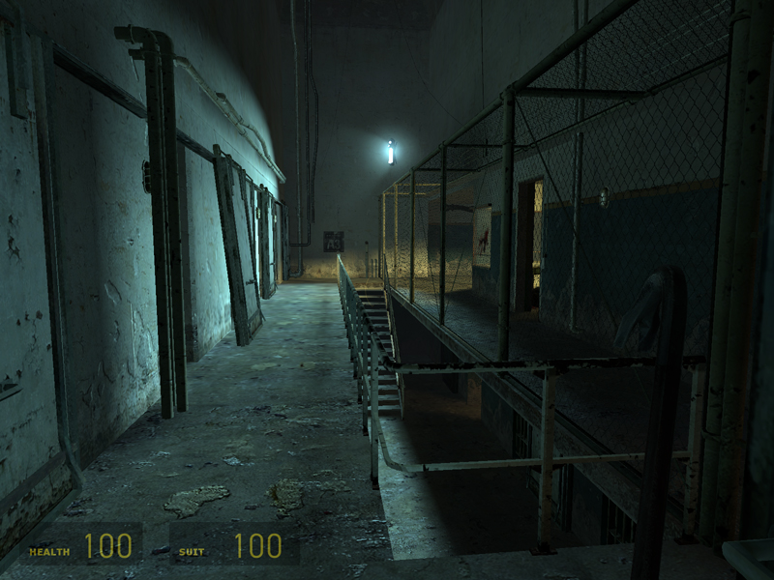
Fig. 1: Cell Block A3 from the Nova Prospekt Chapter (Half-Life 2)

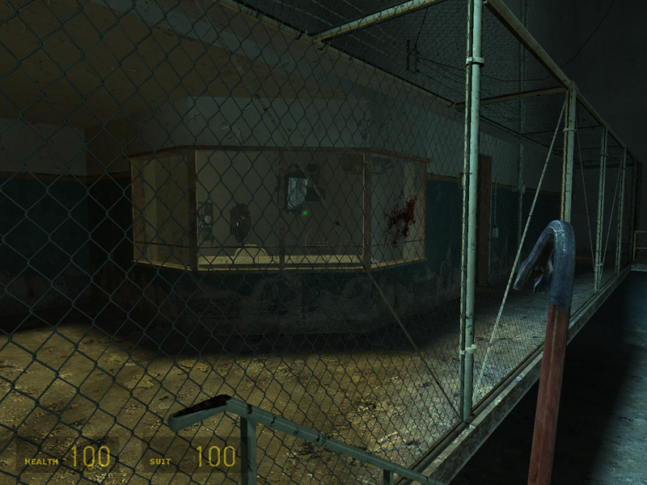
Fig. 2: Security Station in Nova Prospekt. (Half-Life 2)

Fig. 3: Cell Block. (Half-Life 2)

  - Textures/Lighting:

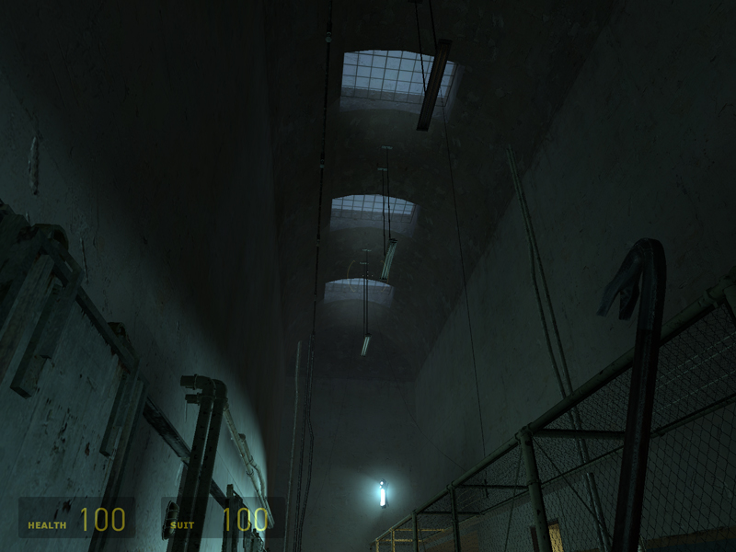
Fig. 4: Skylights from Nova Prospekt, Cell Block A3. (Half-Life 2)

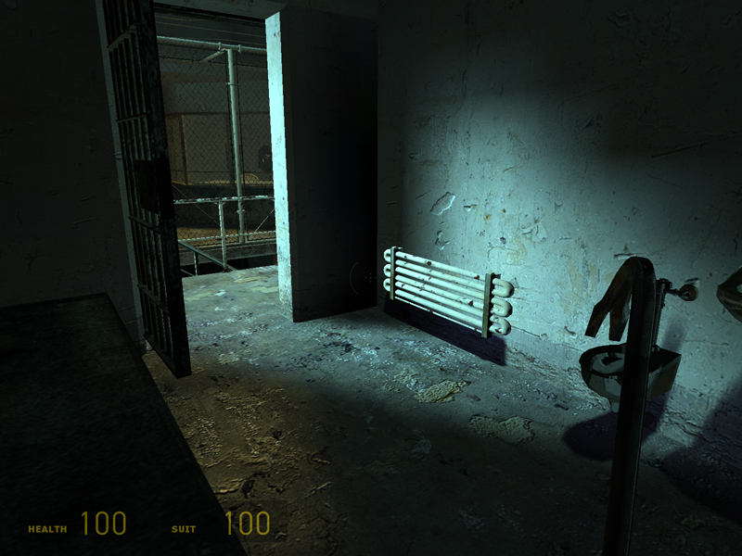
Fig. 5: Lighting from inside one of the cells in Nova Prospekt. (Half-Life 2)

  - Characters/Vehicles:

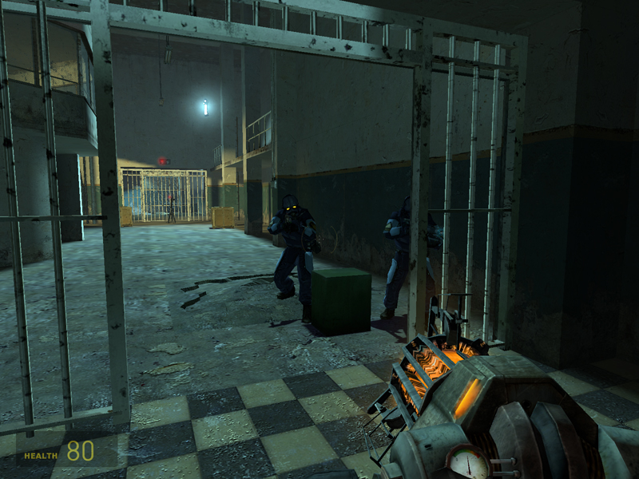
Fig. 6: Combine-S Nova Prospekt Soldiers. (Half-Life 2)

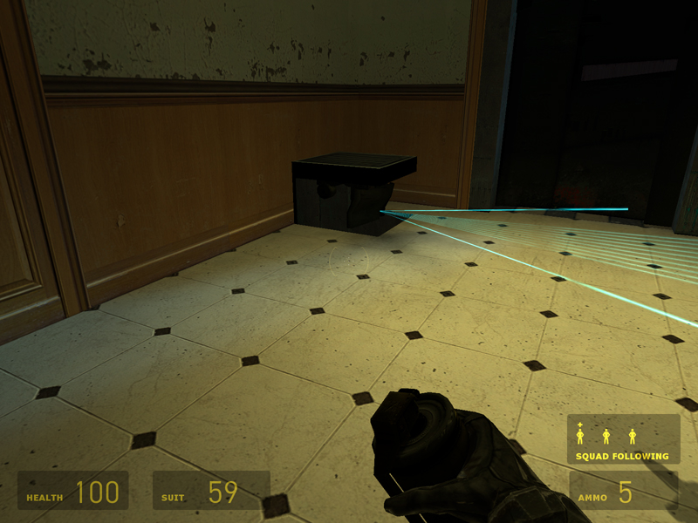
Fig. 7: Floor Turrets (Half-Life 2)

Area B: Prison Yard
- Text Description: The prison yard is more of a long stretch of open ground between the Administration building and Cell Blocks 4 & 5. Sounds of a battle taking place just on the other side of the high prison walls can be heard as soon as the player steps out on to the yard. While most of the guards are focusing on what’s going on outside of the prison, there are still a few intermittent guards patrolling inside the walls. Long beyond its days of active use, the vegetation in the yard is either dead or dying. Automated searchlights pass back and forth across the yard, ready to deploy manhacks at the first sign of trouble.

- Visual References:

  - Terrain/Vegetation: See Figure 8.

  - Models/Architecture:

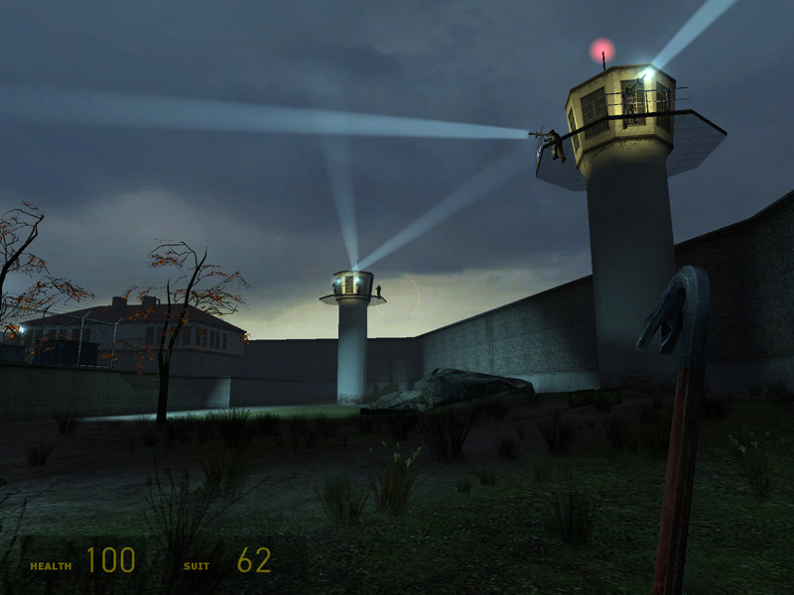
Fig. 8: Prison Yard from Nova Prospekt (End of “Sand Traps” Chapter). Note the high walls, the guard towers, the sparse, dying vegetation, and the searchlights (Half-Life 2).

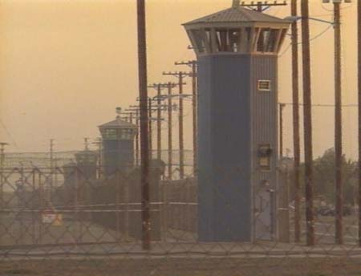
Fig. 9: Prison Towers (location unknown).

  - Textures/Lighting:

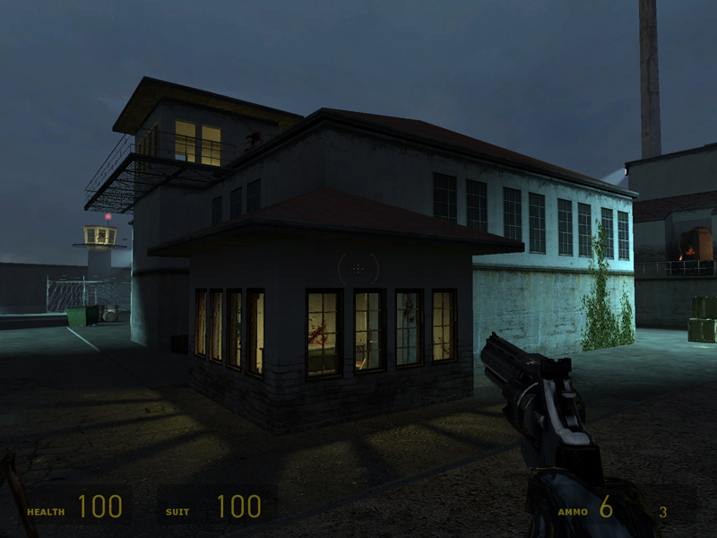
Fig. 10: Prison Building in Nova Prospekt prison yard. Note that while the sky is relatively well light for nighttime, there are still heavy shadows present. Also the architecture of these buildings is similar to the intended architecture for the exteriors of the Admin and Cell Block buildings (Half-Life 2)

  - Characters/Vehicles:

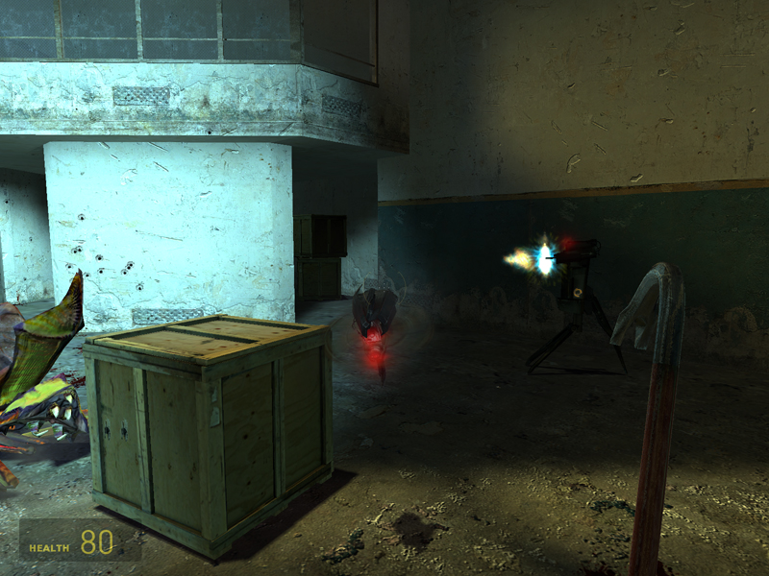
Fig. 11: Manhacks. (Half-Life 2)

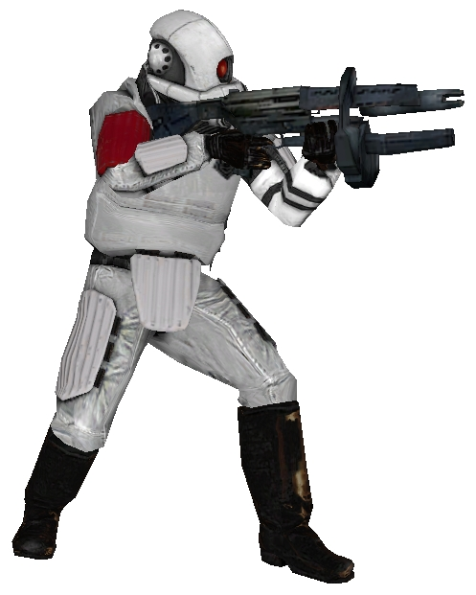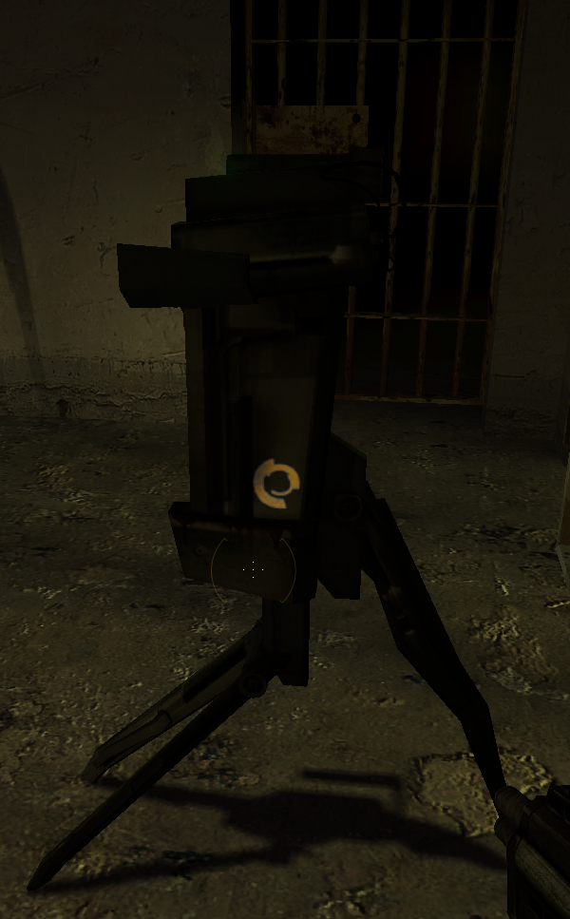
Fig. 12, 13: Combine Elite and Tripod Turrets (Half-Life 2)

Area C, E: Prison Administration
- Text Description: The Combine presence in the Prison Admin building means that there is a bit more Combine tech spread out through the area (consoles, doors, etc), but structurally it still resembles an Eastern European prison structure. Lighting is better in this area since it is still in use.
- Visual References:

  - Terrain/Vegetation: This area contains no terrain or vegetation.

  - Models/Architecture:

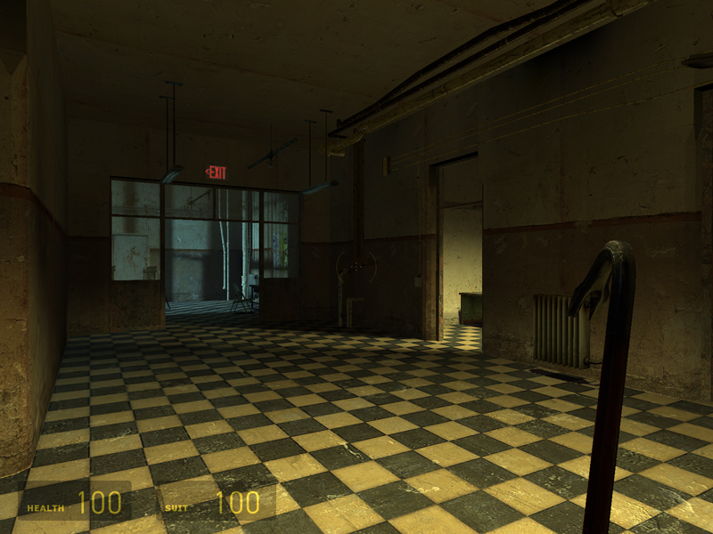
Fig. 14: Hallway from Nova Prospekt. (Half-Life 2)

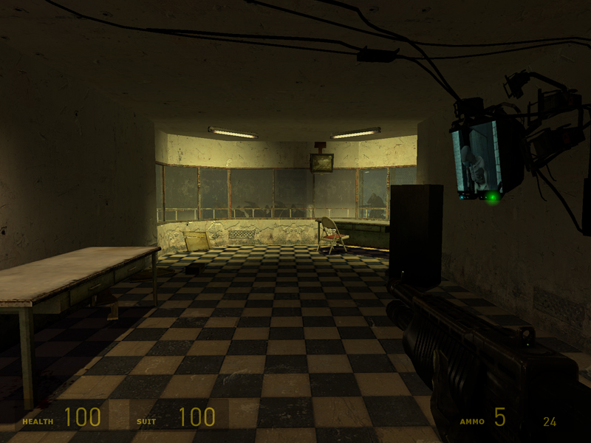
Fig. 15: Office/Watch Station from Nova Prospekt. (Half-Life 2)

  - Textures/Lighting: See above.

  - Characters/Vehicles:
No new characters introduced.

Area D: Lobby
- Text Description: The lobby area has a high, arched ceiling, with 4-6 skylights letting in the moonlight. There are also large, barred windows across the sides of the room. The pre-existing florescent lights are still operational and provide the room with flat, yellow light. When these are turned off (via scripted event), the only light present comes from the moonlight and the occasional spotlight from the battle outside.
- Visual References:

  - Terrain/Vegetation: This area contains no terrain or vegetation.

  - Models/Architecture:

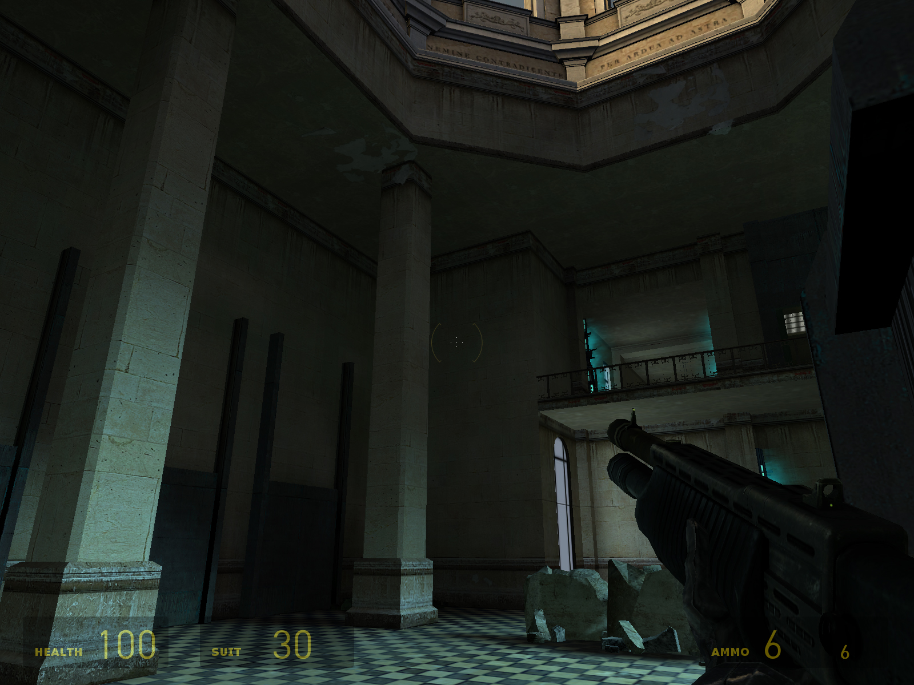
Fig. 16: Lobby of the museum from the “Follow Freeman” chapter. Note the heavy stone pillars and high ceilings. (Half-Life 2)

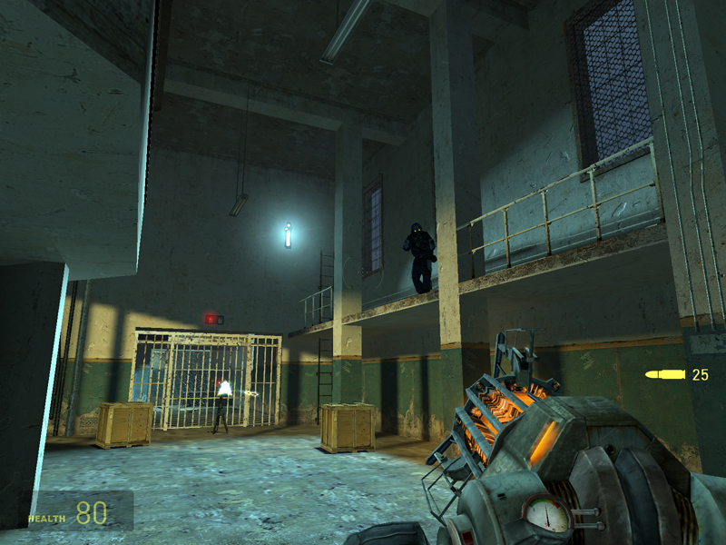
Fig. 17: Similar to Fig. 16, with the inclusion of the high windows to let in moon light or spotlights from outside. (Half-Life 2)

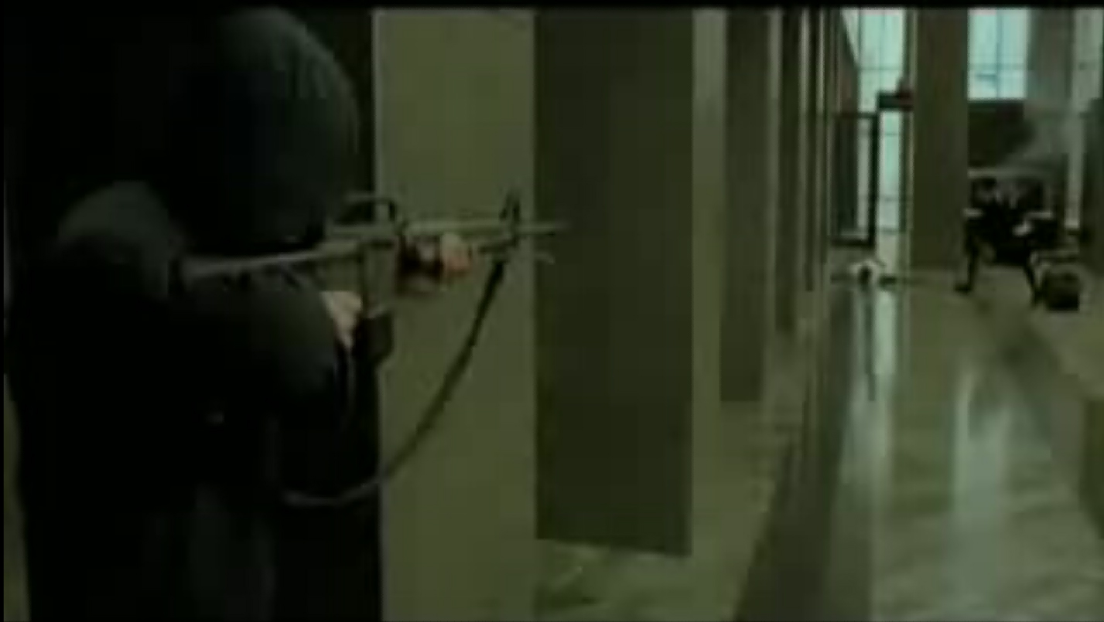
Fig. 18: The lobby layout in this level resembles the lobby from The Matrix.

  - Textures/Lighting: See Figures 16 and 17.

  - Characters/Vehicles:
No new characters introduced.

Map Objectives
- Primary: Escape Nova Sedlo Prison
- Secondary: None.
- Bonus: None.
- Hidden: None.

Challenge Highlights

Combat
- Combat Highlight 1: The player faces two patrolling Combine S troops armed with only a crowbar.
- Combat Highlight 2: The player faces five Combine S troops in the Guard Station area, equipped with a SMG and a crowbar. If the player can manage it, also possible to get through most of this area using stealth kills. The large central structure provides cover. Enemies area spread across two floors.
- Combat Highlight 3: The player faces five Combine S troops in the Cell Block 5 area, this time with slightly better equipment, including a magnum and some grenades. Cell Block 5 is one long hall with sporadic cover provided by misc junk, and by the cells and cell doors. Again, the player is fighting guards on two different floors, but line of sight is generally much clearer than in the Guard Station.
- Combat Highlight 4: If the player is spotted by one of the searchlights or possibly by one of the patrolling guards, then they have to fight off six manhacks and eight elite troops. There is some cover in the yard, but its positioned in a way to provide more of an advantage to the player.
- Combat Highlight 5: The player must fight his way through the Administration building taking on three turrets and four Combine-S guards, spread around the area. This area provides a lot of cover for both the player and the Combine soldiers, since the turrets are set up strategically to face the player on his way to the front lobby.
- Combat Highlight 6: The final battle takes place in the lobby where the player takes on 12 Combine Elite troops that repel in from the roof. The Elite troops come in groups of four, and the lobby’s pillars provide ample cover for the player. After the player kills the last of the Elite troop, two Combine-S troops open the path for the player so he can advance.

Stealth
- Stealth Highlight 1: The first stealth “opportunity” occurs right at the beginning of the level. The player can take out one of the patrolling guards using the crowbar sneak attack.
- Stealth Highlight 2: In the prison yard, the player can make it through the area by avoiding the searchlights and either hiding from or killing the guards.

Puzzles
- Puzzle Highlight 1: The first “puzzle” that the player encounters is in the Security Checkpoint area (A4). The player must use grenades to destroy the floor turrets that guard the area.
- Puzzle Highlight 2: If the player is spotted by one of the searchlights in the prison yard, then they need to explore the newly opened Barracks area (B2) to find the control panel to disable the Energy Shields

Conversation
None.

Boss Battles
None.

Wow Moments
- Wow Moment 1: The Prison Yard provides the first “wow” moment of the level, with its high walls and imposing guard towers. There are signs of a battle going on just the other side of the northern wall (explosions, gunfire, death sounds, possibly soldiers firing from the guard towers). The searchlights that pan across the yard below (and their functionality/use) is more of a gameplay “wow” since if the player is spotted by one of the search lights, the area goes into lockdown and Elite troops are deployed to kill the player.
- Wow Moment 2: The Lobby area is the last combat area of the game, as the player is walking into an ambush. The player is close enough to taste freedom, and suddenly everything goes black and an energy shield shoots up in front of the exit. A single flare falls from the skylight, amplifying the weak moonlight coming in from the windows. Elite troops start to repel into the center the room in groups of four, so the player has to scramble to find cover.

Actors

Player
- Model: Gordon Freeman
- Inventory: Crowbar, Full Health, and Shield Power
- Start Location: Cell Block 4 (A1)
- Motives/Objectives: Escape Nova Sedlo prison.

Key Actors

Manhacks
- Model: Manhack
- Inventory: None
- Motives/Objectives: These small, flying drones attack the player by ramming into them. In this mission, manhacks attack the player when he has been spotted by one of the searchlights in the prison yard.
- Starting Location: B

Combine-S (Nova Prospekt)
- Model: Combine S
- Inventory: Shotgun or SMG, Health +15
- Motives/Objectives: Combine heavy infantry troops, well-armored and well-equipped. Combine-S troops guard all areas of the prison and have orders to shoot on sight.
- Starting Location: A-E

Combine Elite
- Model: Combine Elite
- Inventory: Shotgun or AR2, Health +15
- Motives/Objectives: Special Forces version of the standard Combine troop. Rappel from the roof when the player is trapped in the Lobby area. Also may appear in the Prison Yard area if the player is spotted by one of the searchlights.
- Starting Location: B, D

Floor Turret
- Model: Floor Turret
- Inventory: None
- Motives/Objectives: These turrets pop out of the floor when the player hits a laser trip wire and can only be destroyed using a well-thrown grenade. These appear once near the entrance to the Prison Yard at the end of Area A. Starting Location: A

(Tripod) Turret
- Model: Tripod Turret
- Inventory: None
- Motives/Objectives: The standard Combine tripod turret. Easily tipped over with a well-timed crowbar swipe. These appear in the Administration building.
- Starting Location: C

Supporting Actors
N/A

Key Assets
- Weapons/Ammo:
  - Crowbar (Starting)
  - .357 Magnum (Obtained in Guard Station, A2)
  - SMG (Obtained from Enemy)
  - Grenades (Obtained in Guard Station, A2)
  - Shotgun (Obtained from Enemy)
  - AR2 (Obtained from Enemy)
  - SMG Ammo (Obtained from Enemy)
  - AR2 Ammo (Obtained from Enemy)
  - Shotgun Ammo (Obtained from Enemy)
  - Health (Obtained from Enemy)
- Vehicles: None.
- Interactive Elements: None.

User Interface
- Pre-Game Information
  - This mission contains no external cutscenes or information.
- In-Game Information
  - Message 1: Displayed as soon as the mission starts: "Escape Nova Sedlo Prison."
- Post Game Information
  - This mission contains no external cutscenes or information.
- HUD Elements
  - Normal Elements Used: All
  - Special Elements Required: None

Gameplay Details

Gameplay Mechanics
- Prerequisite Skills
  - Movement
  - Crowbar Operation
  - Pistol/Magnum Operation
  - Shotgun Operation
  - Grenade Operation
  - SMG/AR2 Operation
  - Knowledge of how to destroy floor turrets
- Skills Learned
  - Basic Stealth Avoidance
  - Stealth Kills

Level Progression Chart
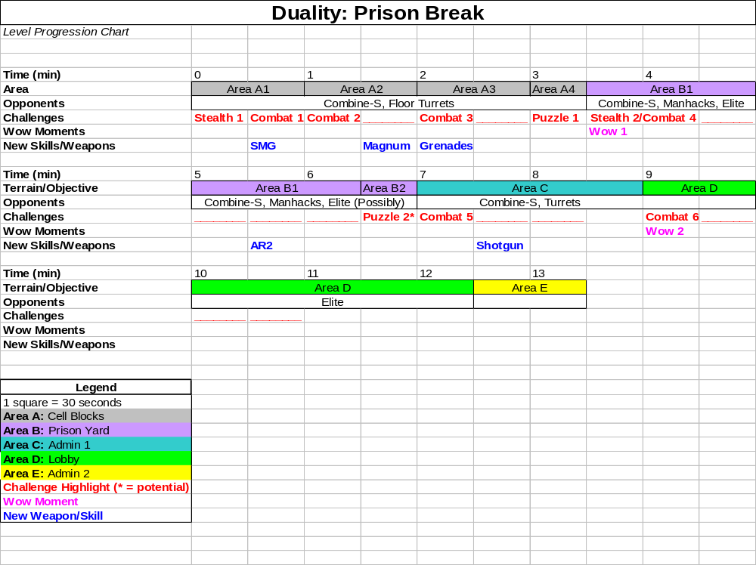

Level Thumbnail
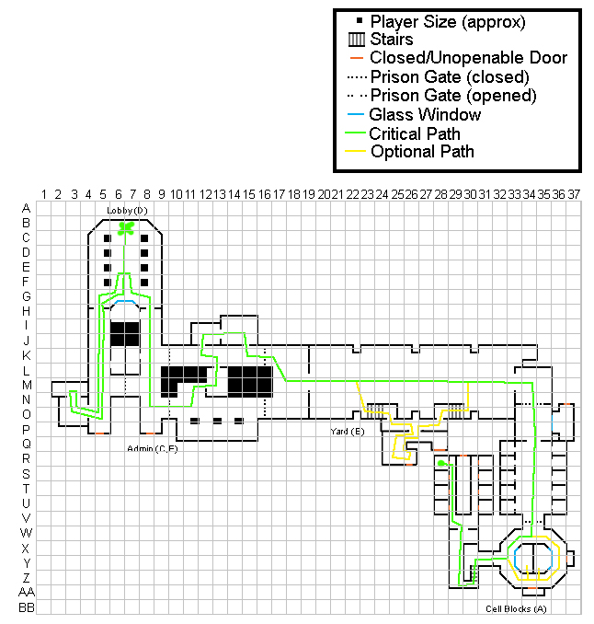

Walkthrough/Detailed Map Description

Area A: Cell Blocks Map

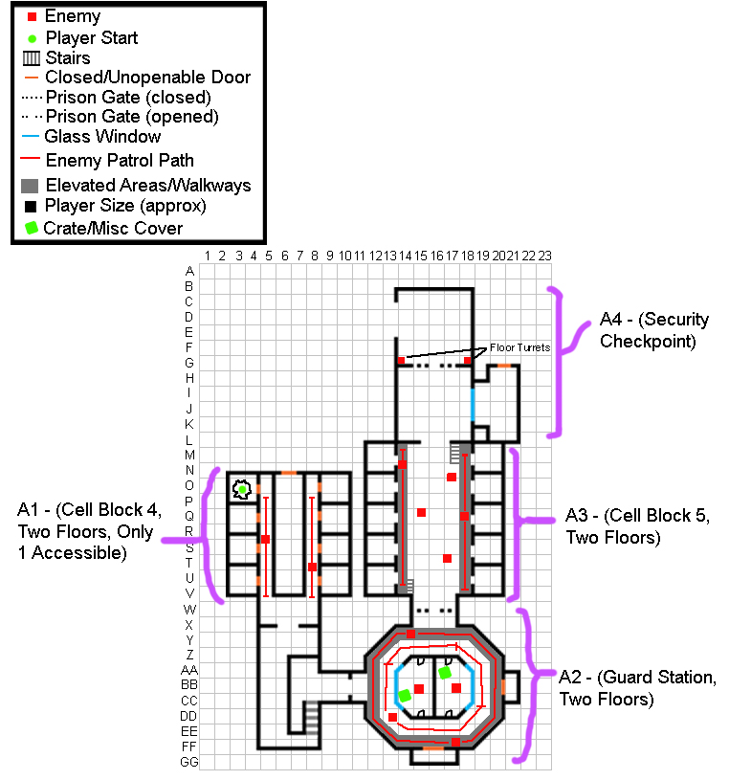

Area A1: Cell Block 4 Walkthrough
- Exploration: The level begins in a dilapidated prison cell where the player has (presumably) just fallen through the ceiling. The player is equipped with only a crowbar. As soon as play begins, Message 1 is displayed.
- Message 1: “Escape Nova Sedlo Prison”
- Stealth/Combat Highlight 1: The player must use their only weapon at this point, the crowbar, to take down one of the Combine soldiers patrolling in the area to get a better weapon. While a stealthy approach is encouraged, the player can still simply rush one or both of the guards.

- Visual References: See Area A.

Area A2: Guard Station Walkthrough
- Exploration: From Area A1, the player enters the large Guard Station, which has five guards on two different floors, with three patrolling around the area and two standing watch.
- Combat Highlight 1: While the player can take down the guards one-by-one using the crowbar, the visibility of the area and relatively clear lines of sight make it relatively difficult to go unseen.
- Exploration: After defeating the Combine soldiers in the area, the player can search the station to find a grenade ammo box and a magnum.

- Visual References: See Area A.

Area A3: Cell Block 5 Walkthrough
- Exploration: After exiting the Guard Station, the player encounters a similar situation where Combine-S guards are patrolling on elevated walkways to the either side of the cellblock. The individual cells act as safe areas for the player and provide temporary shelter.
- Combat Highlight 2: The player has to take on five Combine-S guards from two sides. The cells and cell doors provide intermittent cover for both the player and the guards.
- Exploration: This Cell Block is mostly empty with the exception of a small health cache hidden in one of the cells.

- Visual References: See Area A.

Area A4: Security Checkpoint Walkthrough
- Puzzle Highlight 1: The first “puzzle” is relatively simple, where the player has to take out two floor turrets near the exit to the Prison Yard using grenades.

- Visual References: See Area A.

Area B: Prison Yard Map
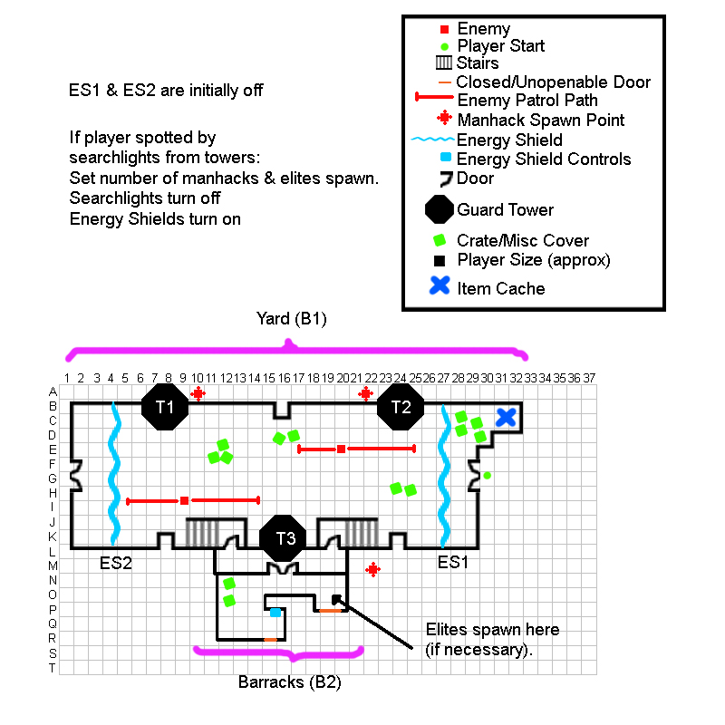
Area B1: Prison Yard Walkthrough
- Wow Moment 1: The prison yard itself is the first “wow” moment of this level and it is essentially a combination of gameplay and visuals. The high walls, guard towers, and search lights lead the player’s view upwards, and sounds of the battle going on between Resistance fighters and Combine just over the Northern wall contributes to the sight. The searchlights also serve a practical purpose, since, if the player strays into one of them, the area goes into lockdown, with the energy shields at ES1 and ES2 turning on. Manhacks fly in from the guard towers, and Combine Elite soldiers come in from the doors to the south.
- Exploration: If the player searches the area around the Cell Block 5 exit, they can find a small ammo cache. (C31)
- Stealth Highlight 2: If the player manages to avoid the searchlights for the entirety of this area, then this is a stealth highlight; if they are spotted, then it turns into a combat highlight. The stealth highlight involves merely avoiding the automated/pathed searchlights. Depending on the difficulty of implementation, the player may also have to avoid being seen by the two Combine-S soldiers in the area.
- Combat Highlight 4: If the player is spotted by one of the searchlights, a number of things occur:
  - Energy Shields ES1 & ES2 turn on.
  - Two Manhacks are deployed from each of the guard towers (T1, T2, T3) (Six total)
  - Eight Combine Elite soldiers come in from the small barracks area near T3.
  - The searchlights turn off, and alarms turn on.

Area B2: Barracks Walkthrough
- Puzzle Highlight 2: If the player sets off the alarm, in order to progress, they need to go into the barracks area near T3 and disable the Energy Shields using the control panel in this room.

- Visual References: See Area B and below.

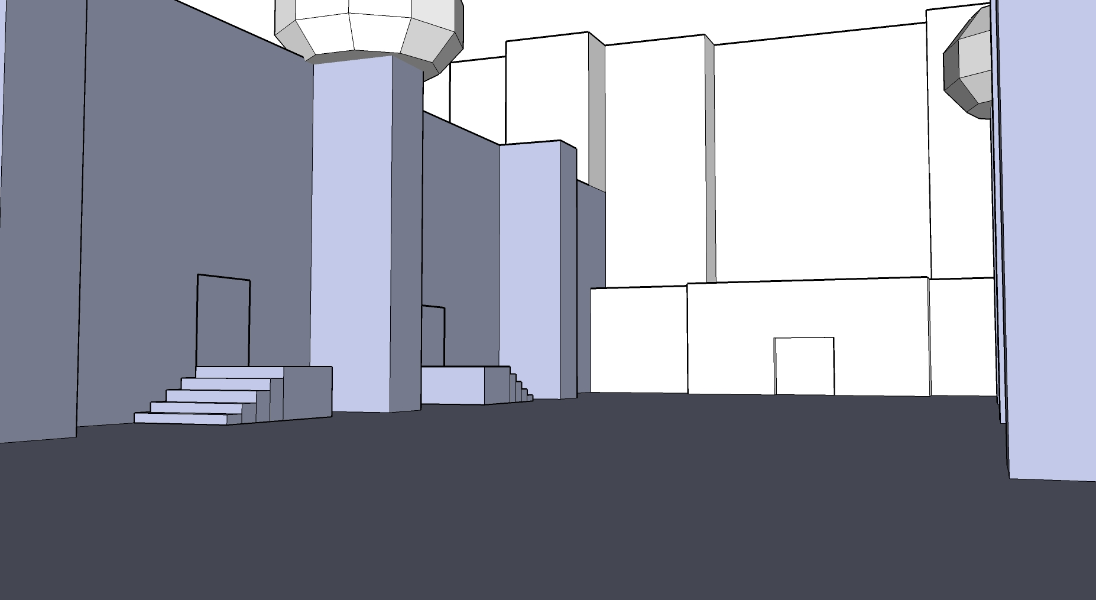
Fig. 19: SketchUp diagram of view from Cell Blocks exit.

Area C/E: Administration Building Map
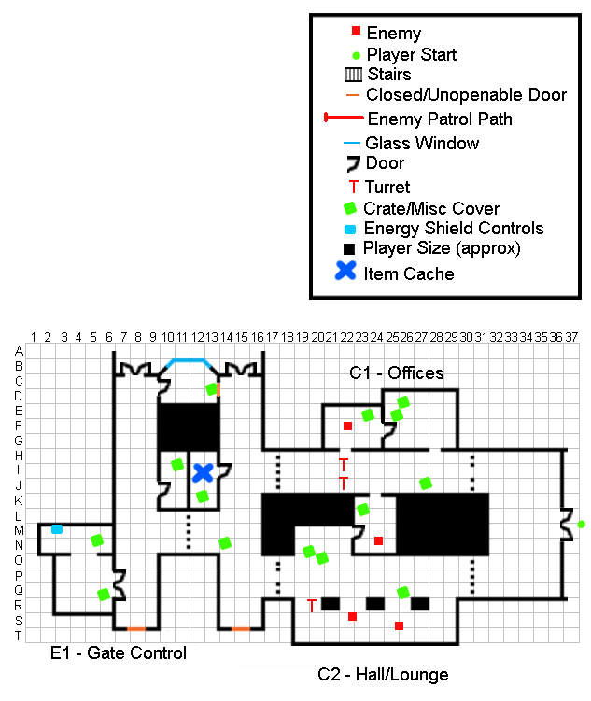
Area C1: Administration Building Offices Walkthrough
- Combat Highlight 5: Considering the potentially difficult situation that they player has just escaped from in the prison yard, the combat in this area is relatively light and mainly involves stationary turrets. The player must find a way to disable two turrets at the end of the hall (H22). They can outflank the turrets by dashing into the neighboring office, run past them, or attack them directly, though this is more difficult without the gravity gun. In addition to the two turrets, there are also two nearby Combine-S guards.

- Visual References: See Area C/E.

Area C2: Administration Building Hall/Lounge Walkthrough
- Combat: (Continuation of Combat Highlight 5) After either avoiding or disabling the two turrets in area C1, the player enters a small lounge/break room where he’s greeted by another turret (R20). The player can choose to hide behind some of the nearby cover or make a break for it.
- Exploration: There is a small storage closet behind the last turret that holds a small health, armor and ammo cache. (I11)

- Visual References: See Area C/E.

Area D: Lobby Map
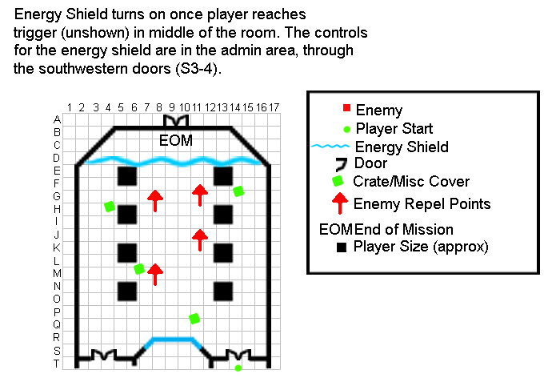
Area D: Lobby Walkthrough
- Wow Moment 2/Combat Highlight 6: The 2nd “Wow” moment in the level occurs in the lobby area, where the player can almost taste freedom. There are signs of combat right outside the front entrance. Unfortunately for the player, Combine forces have been expecting him and mid-way through the lobby, an energy shield activates and blocks the exit. The power is cut off, leaving only the ambient light which is peeking in from outside. Flares drop from the skylights, and 12 Combine Elite troops repel in to the room (in groups of 4). After the player has defeated the last of the Elite troops, two Combine-S guards unlock the southwestern doors and attack the player. This opens up the path back into the Administration building and the controls for the Energy Shield which blocks the entrance.

- Visual References: See Area D.

Area E1: Administration Building Gate Control Walkthrough
- Exploration: The last area for the player simply requires that they find the control panel for the energy shield in the lobby, which is in the southwestern area of the Administration Building (the only area new area the player can access at this point). After hitting the switch, the player heads back to the lobby and the level ends.

- Visual References: See Area C/E.

